**VISVESVARAYA TECHNOLOGICAL UNIVERSITY**

**“JnanaSangama”, Belgaum -590014, Karnataka.**



**LAB REPORT**

**on**

**INTERNET OF THINGS**

***Submitted by***

**MD SURAJ KUMAR(1BM20CS079)**

***in partial fulfillment for the award of the degree of***

**BACHELOR OF ENGINEERING**

***in***

**COMPUTER SCIENCE AND ENGINEERING**



**B.M.S. COLLEGE OF ENGINEERING**

**(Autonomous Institution under VTU)**

**BENGALURU-560019**

**Oct 2022-Feb 2023**

**B. M. S. College of Engineering,**

**Bull Temple Road, Bangalore 560019**

(Affiliated To Visvesvaraya Technological University, Belgaum)

**Department of Computer Science and Engineering**



**CERTIFICATE**

This is to certify that the Lab work entitled “**INTERNET OF THINGS**”carried out by **MD SURAJ KUMAR(1BM20CS079),** who is a bonafide student of **B. M. S. College of Engineering.** It is in partial fulfillment for the award of **Bachelor of Engineering in Computer Science and Engineering** of the Visvesvaraya Technological University, Belgaum during the year 2022-23. The Lab report has been approved as it satisfies the academic requirements in respect of Internet of Things Lab **- (20CS5PEIOT)** work prescribed for the said degree.

**Dr.K.Panimozhi**          **Dr. Jyothi S Nayak**

Assistant Professor Professor and Head

Department of CSE Department of CSE

BMSCE, Bengaluru BMSCE, Bengaluru

Program no: **01**                        Program Title: **LED BLINK**

**Aim:** To control the LED using arduino ( to turn ON/OFF LED)

**Components Required :**

Arduino Uno board - 1

USB Cable - 1

LED - 1

Jumper wires

**Pin connection :**

* LED's positive leg is connected to digital pin 13
* LED's negative leg is connected to ground

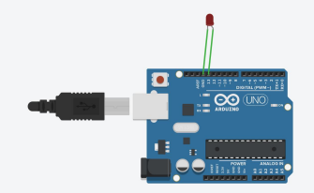

**Code :**

void setup()

{

pinMode(13, OUTPUT);

}

void loop()

{

digitalWrite(13, HIGH);

delay(1000);

digitalWrite(13, LOW);

}

**Handwritten code :**

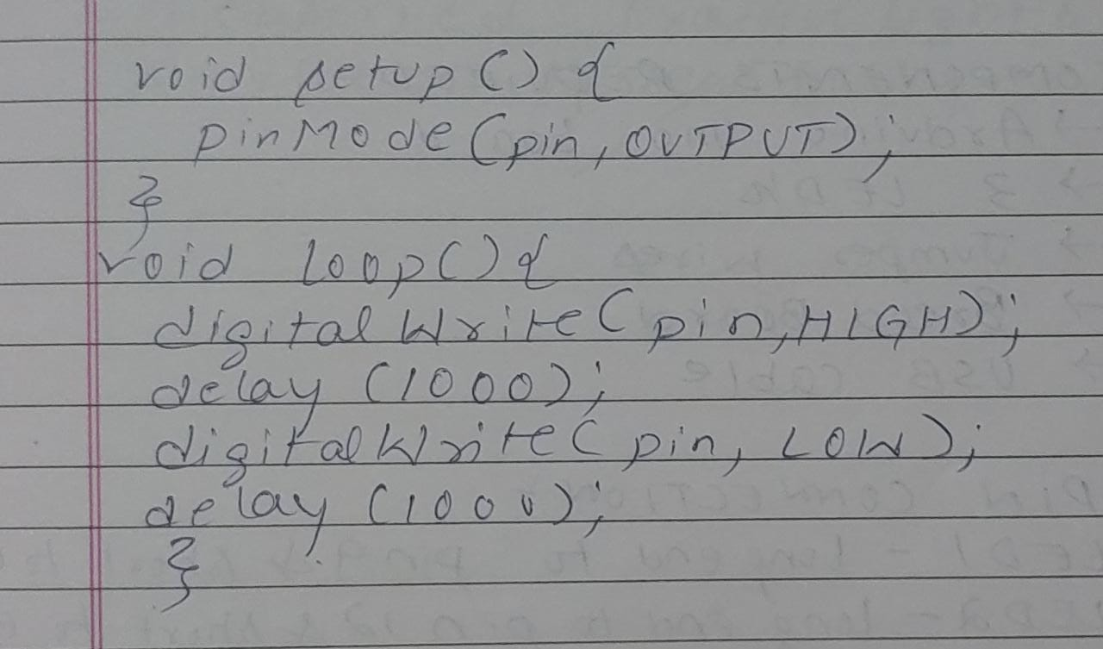

**Observation:** LED switches ON/OFF periodically. Digital output visualization using Arduino Uno.

Program no: **02** Program Title: **TRAFFIC SIGNAL**

**Aim :**To simulate traffic signal scenario using an arduino UNO board

**Components Required :**

Arduino Uno board - 1

USB Cable - 1

LED - 3

Jumper wires

**Pin Connections :**

* LED(RED) positive pin to digital pin 13
* LED(Yellow) positive pin to digital pin 12
* LED(Green) positive pin to digital pin 11
* LED(ALL) negative pin to Ground

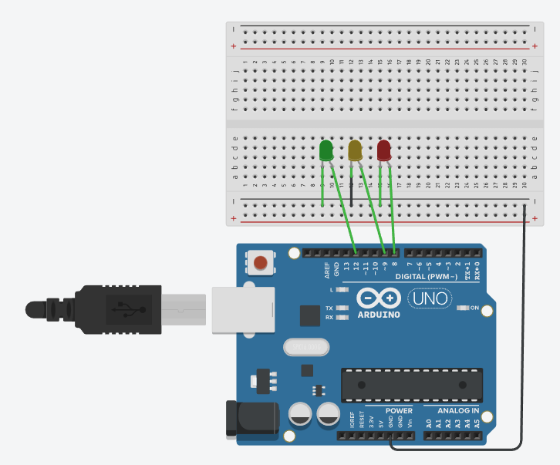

**Code :**

void setup()

{

pinMode(9, OUTPUT);

pinMode(12,OUTPUT);

pinMode(8,OUTPUT);

}

void loop()

{

digitalWrite(9, HIGH);

delay(1000);

digitalWrite(9, LOW);

delay(1000);

digitalWrite(12, HIGH);

delay(1000);

digitalWrite(12, LOW);

delay(1000);

digitalWrite(8, HIGH);

delay(1000);

digitalWrite(8, LOW);

}

**Handwritten code :**

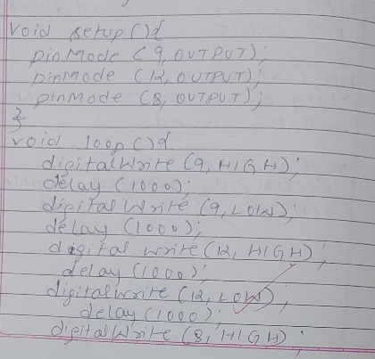

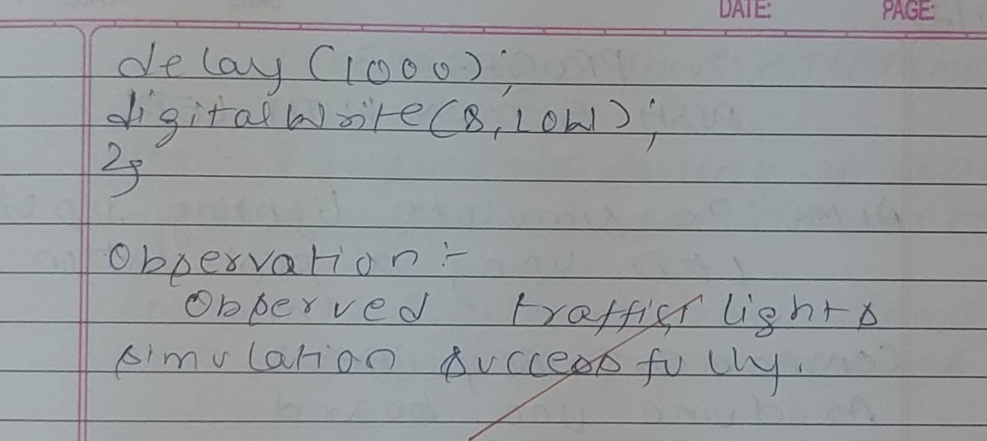

**Observation:** Each of the LEDs switch ON/OFF periodically.

Program no: **03** Program Title: **PUSH BUTTON**

**Aim :**To simulate LED blink using digital input.

**Components Required :**

Arduino Uno board - 1

USB Cable - 1

Breadboard - 1

Push Button - 1

LED - 1

Jumper wires

**Pin Connections :**

* PUSH Button one pin to digital pin 2
* PUSH Button opposite pin of pin 2 to ground
* PUSH Button adjacent pin of ground 5v of arduino
* LED positive pin to digital pin 13
* LED negative pin to Ground

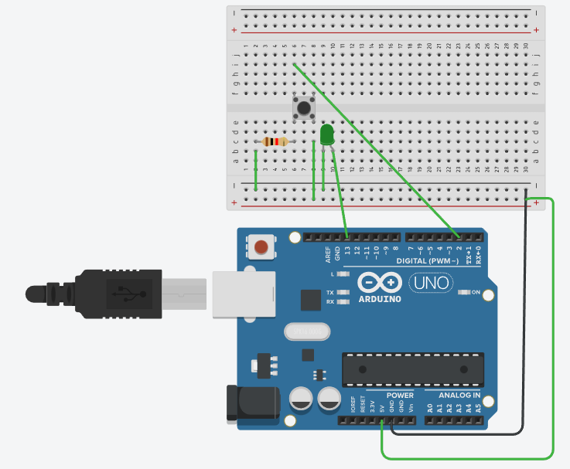

**Code :**

int pushButtonPin = 2;

int ledPin = 13;

void setup()

{

pinMode(pushButtonPin,INPUT);

pinMode(ledPin,OUTPUT);

}

void loop() {

int pushButtonState = digitalRead(pushButtonPin);

if (pushButtonState == 1)

{

digitalWrite(ledPin, HIGH);

}

else

{

digitalWrite(ledPin, LOW);

}

}

**Handwritten code :**

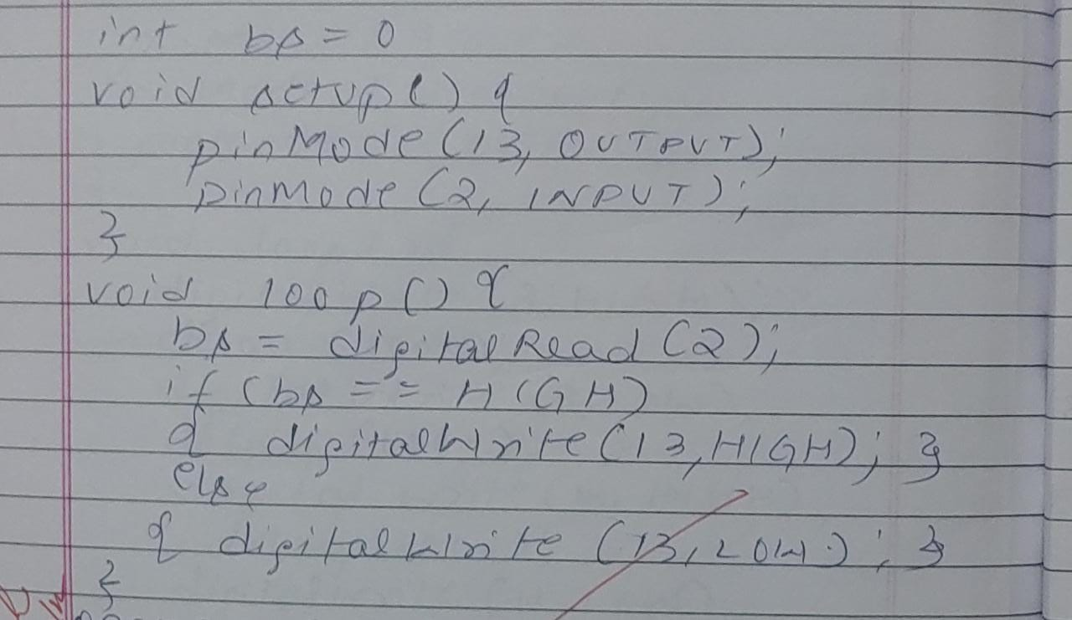

**Observation:** The LED switches ON/OFF periodically when input is given through the push button.

Program no: **04** Program Title: **LED FADE**

**Aim :**To demonstrate analog output with fading LED

**Components Required :**

Arduino Uno board - 1

USB Cable - 1

LED - 1

Jumper wires

**Pin Connections :**

* LED positive pin to digital pin 9
* LED negative pin to Ground

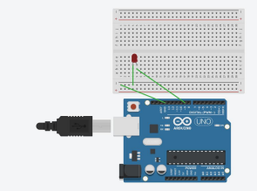

**Code :**

const int LedPin = 9;

void setup()

{

pinMode(LedPin, OUTPUT);

}

void loop()

{

for(int fade value = 0; fade value <= 255; fade value += 255);

{

analogWrite(LedPin, fade value);

delay(330);

}

for(int fade value = 255; fade value <= 0; fade value -= 255);

{

analogWrite(LedPin, fade value);

delay(330);

}

}

**Handwritten code :**

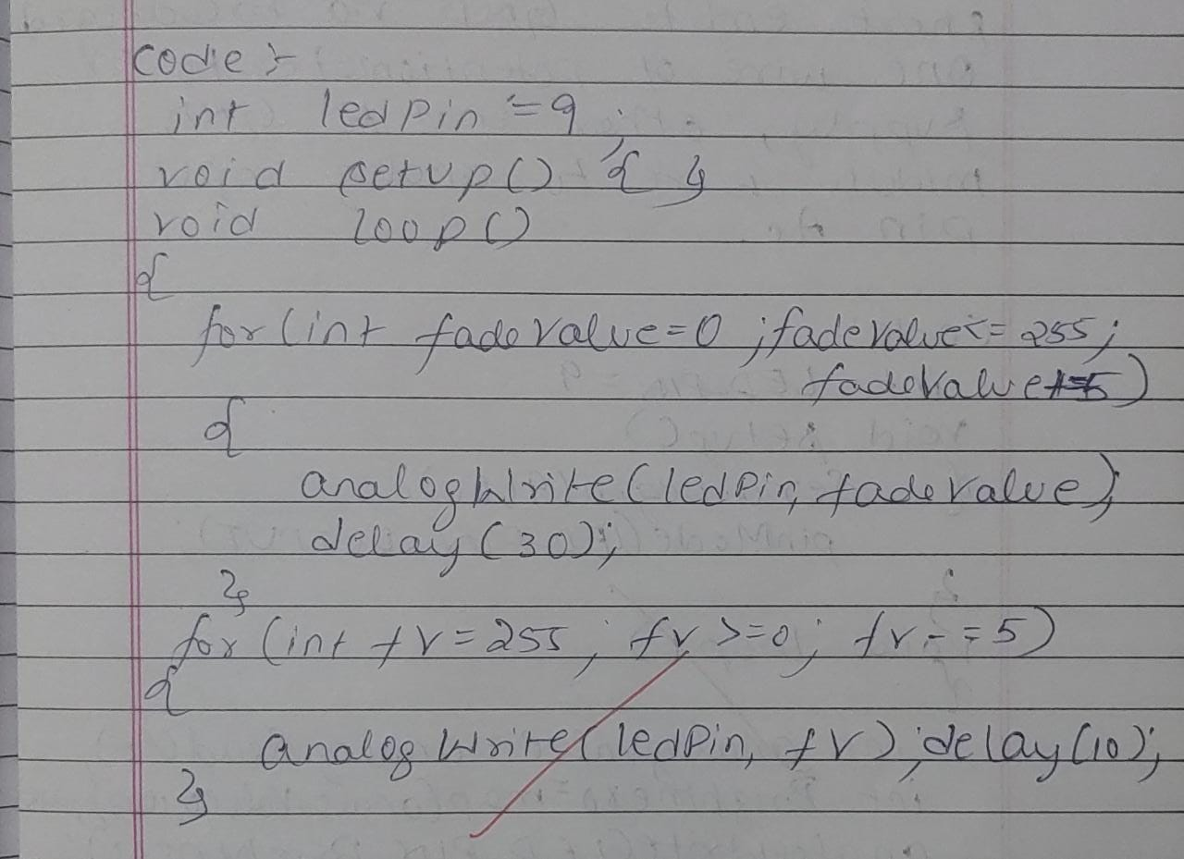

**Observation:** The LED gradually fades away.

Program no: **05** Program Title: **LED FADE WITH POTENTIOMETER**

**Aim :**To demonstrate analog output with fading LED using potentiometer

**Components Required :**

Arduino Uno board - 1

USB Cable - 1

LED - 1

Potentiometer - 1

Jumper wires

**Pin Connections :**

* LED positive pin to digital pin 11
* LED negative pin to analog pin 10
* Potentiometer and LED negative pin to ground

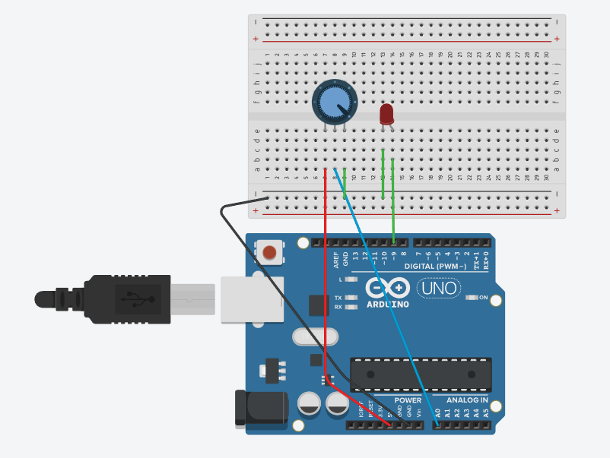

**Code :**

const int LedPin = 11;

void setup()

{

pinMode(LedPin, OUTPUT);

Serial.begin(9600);

}

void loop()

{

int fade value = analogRead(A0);

int brightness = map(fade value 0,1023,0,255)

analogWrite(LedPin, brightness);

Serial.print(“analog”);

Serial.println(fade value);

Serial.print(“brightness”);

Serial.println(brightness);

delay(2);

}

}

**Handwritten code :**

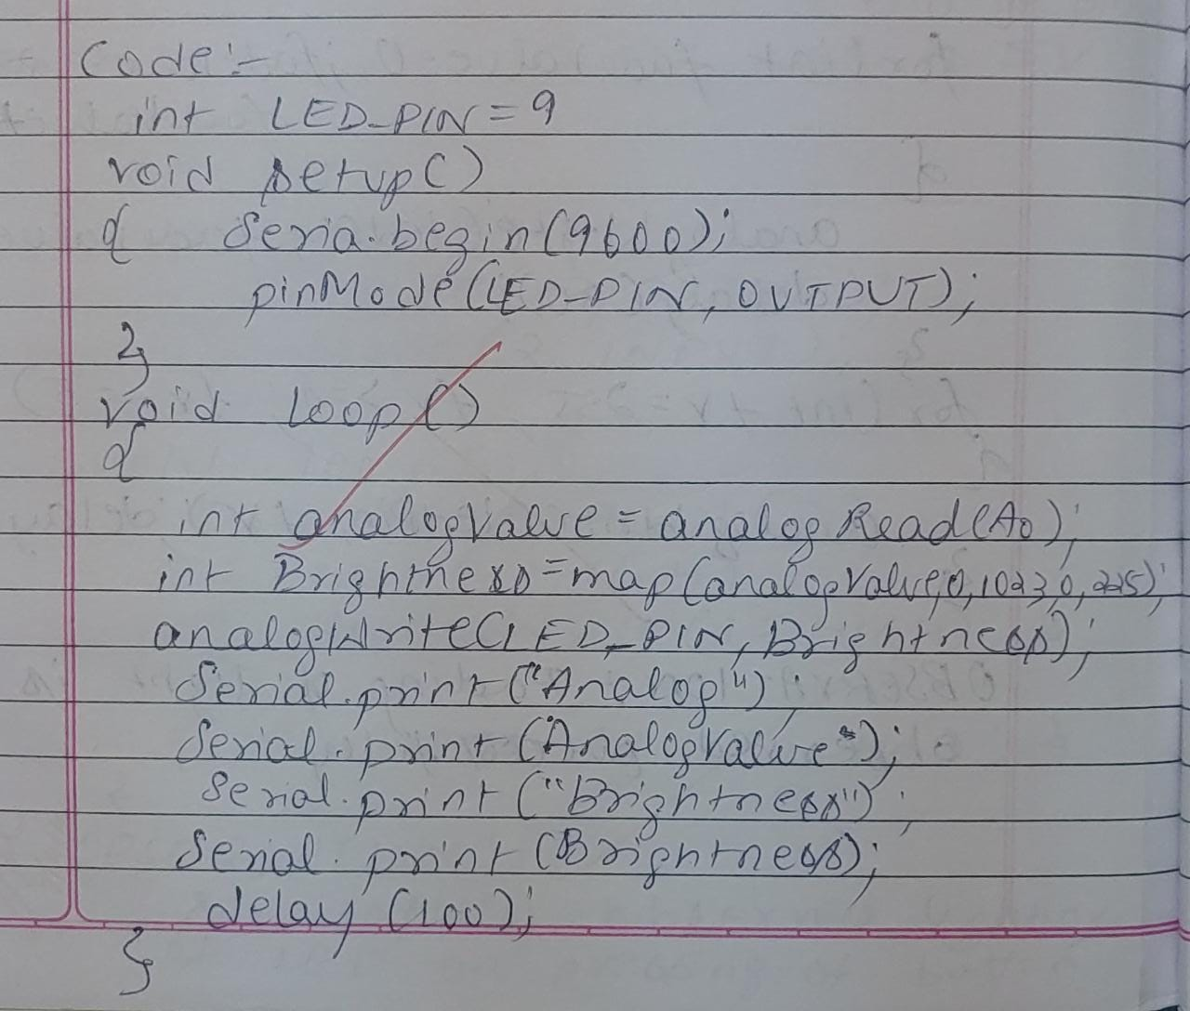

**Observation:** The LED gradually flows and fades according to potentiometer input.

Program no: **06** Program Title: **FADING OF 2 LEDs**

**Aim :**To demonstrate analog output with fading two LED

**Components Required :**

Arduino Uno board - 1

USB Cable - 1

LED - 2

Jumper wires

**Pin Connections :**

* LED green positive pin to digital pin 9
* LED red positive pin to digital pin 11
* Both LED’s negative pin to Ground

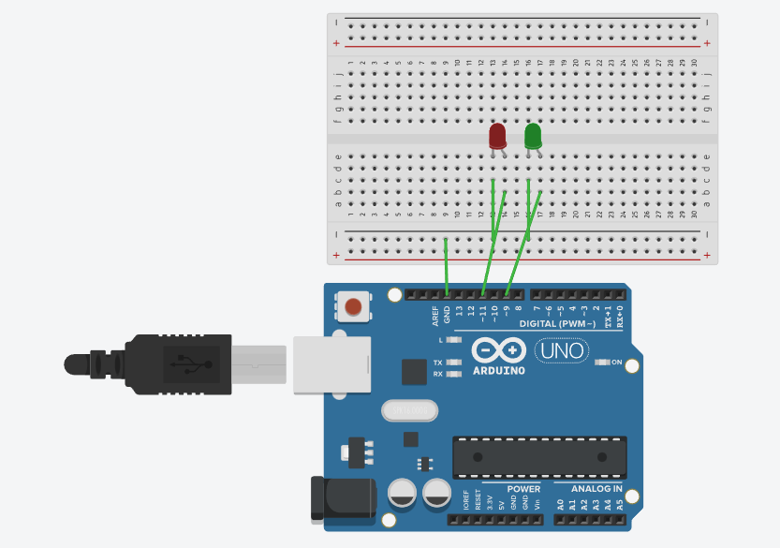

**Code :**

const int LedPin1 = 9;

const int LedPin2 = 11;

void setup()

{

pinMode(LedPin1,OUTPUT );

pinMode(LedPin2,OUTPUT );

}

void loop()

{

for(int fade value = 0; fade value <= 255; fade value += 255);

{

analogWrite(LedPin 1, fade value);

delay(100);

}

for(int fade value = 255; fade value >= 0; fade value -= 15);

{

analogWrite(LedPin 2, fade value);

delay(100);

}

for(int fade value = 255; fade value >= 0; fade value -= 15);

{

analogWrite(LedPin 1, fade value);

delay(1000);

}

for(int fade value = 255; fade value >= 0; fade value += 15);

{

analogWrite(LedPin 2, fade value);

delay(1000);

}

}

**Handwritten code :**

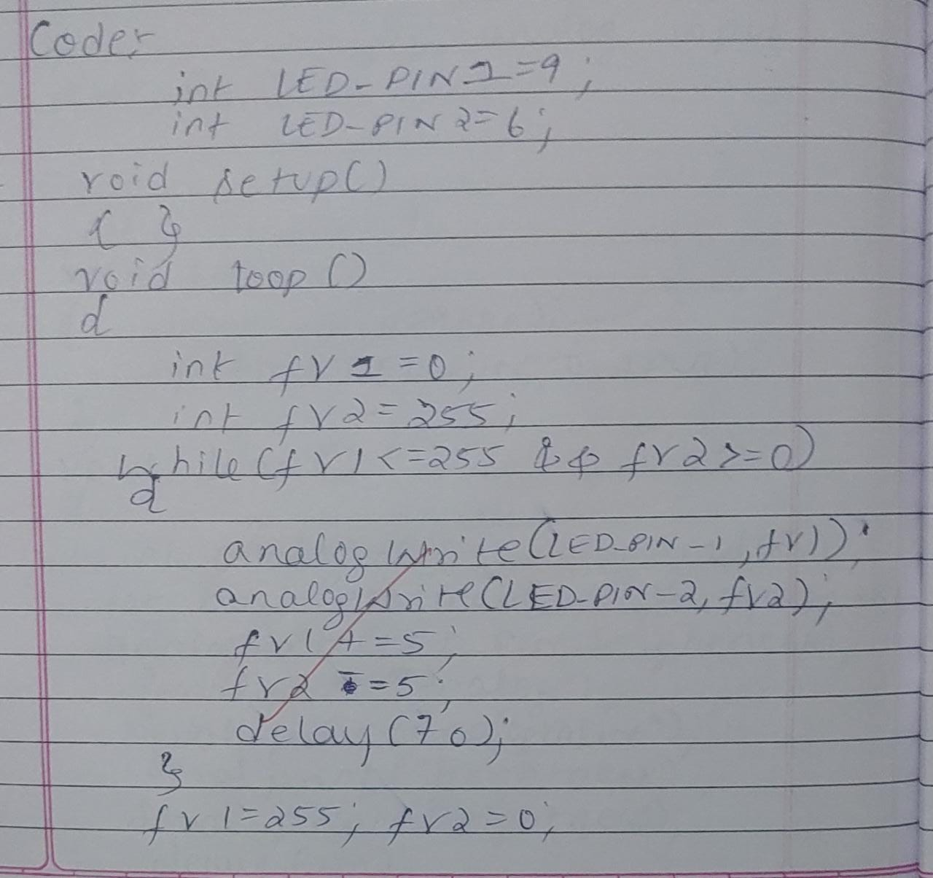

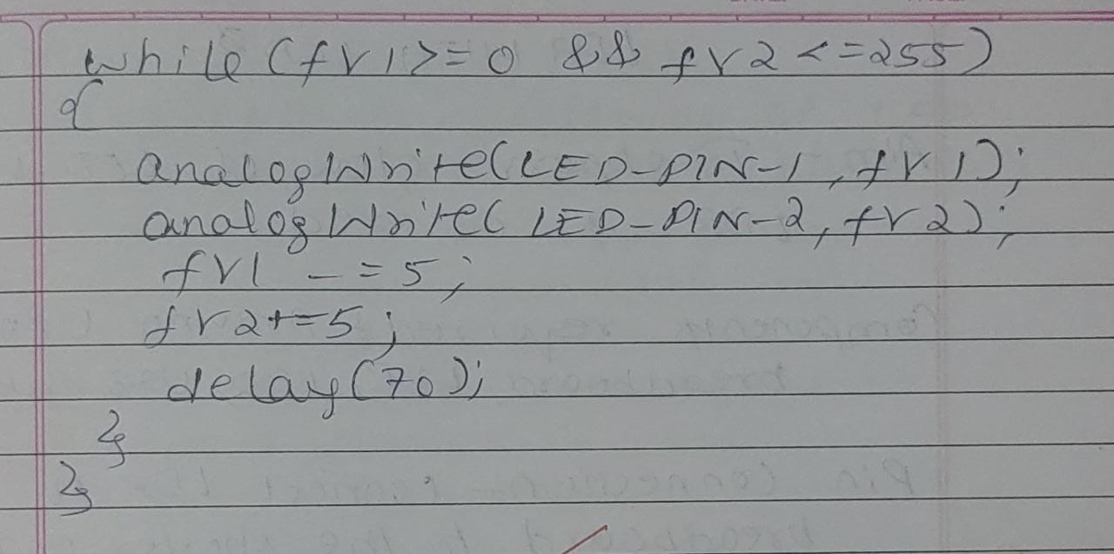

**Observation:** One LED flows and glows, while the other fades away simultaneously.

Program no: **07** Program Title: **LED WITH LDR CONTROL**

**Aim :**To demonstrate LED with LDR control

**Components Required :**

Arduino Uno board - 1

Resistor - 1

USB Cable - 1

LED - 1

Breadboard -1

LDR - 1

Jumper wires

**Pin Connections :**

* LED positive pin to digital pin 13
* LED negative pin to ground
* Positive leg of LDR to A0
* Negative leg of LDR to 5V
* Resistor negative leg to ground
* Resistor positive leg to 5V

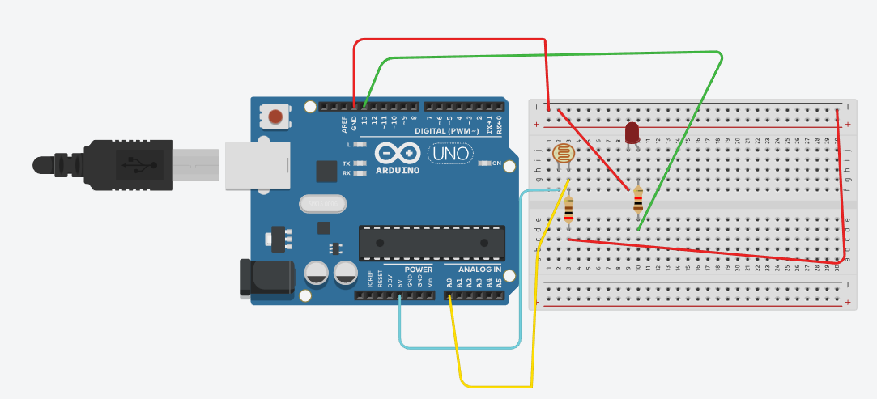

**Code :**

int value = 0;

void setup()

{

pinMode(11, OUTPUT);

pinMode(A0, INPUT);

Serial.begin(9600);

}

void loop()

{

value = analogRead(A0);

if(value < 50 );

{

digitalWrite(11,HIGH)

Serial.println(“Light in ON”);

Serial.print(value);

}

else

{

digitalWrite(11,LOW)

Serial.println(“Light in OFF”);

Serial.print(value);

}

}

**Handwritten code :**

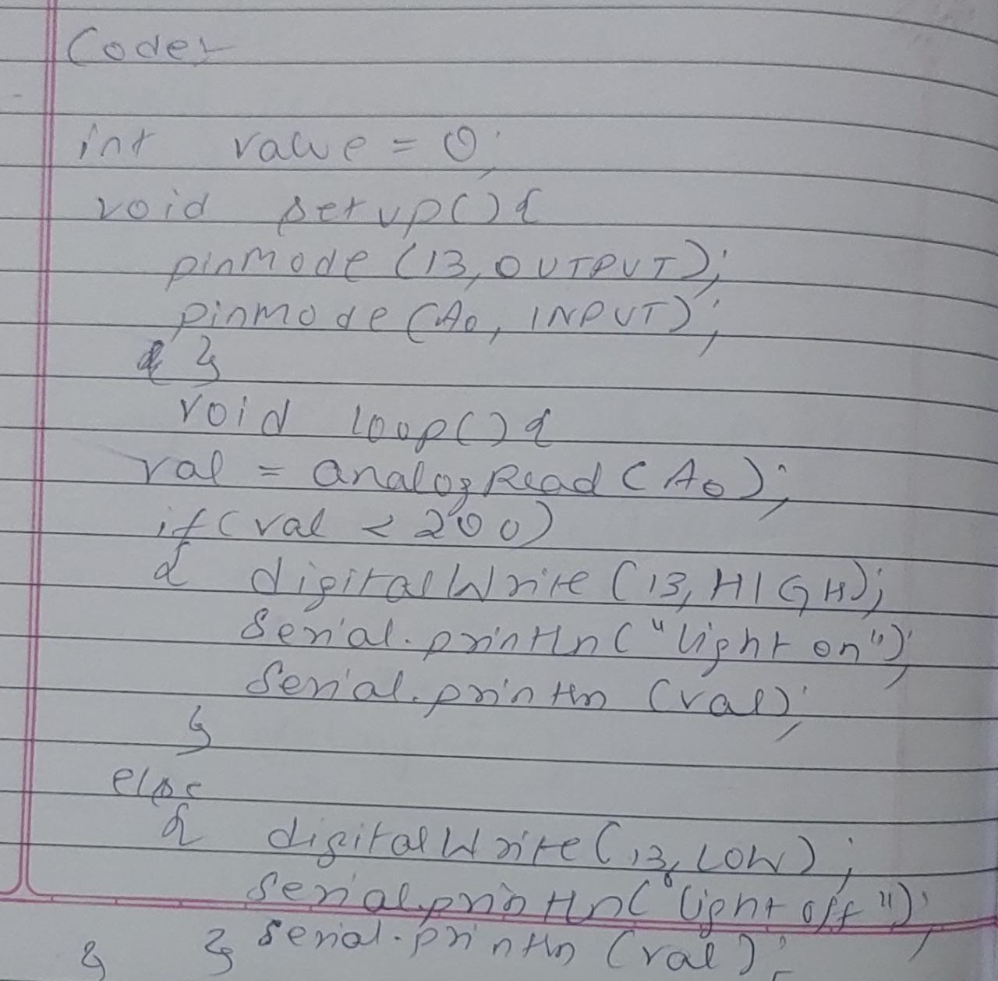

**Observation:** The LED glows when LDR is kept in the dark

Program no: **08** Program Title: **TEMPERATURE SENSOR**

**Aim :**To sense the temperature of the environment

**Components Required :**

Arduino Uno board - 1

USB Cable - 1

LED - 1

Temperature Sensor - 1

Jumper wires

**Pin Connections :**

* Center leg of Temperature sensor to A0.
* Right leg of Temperature sensor to 5V.
* Left leg of Temperature sensor to ground.
* Led positive leg to ground

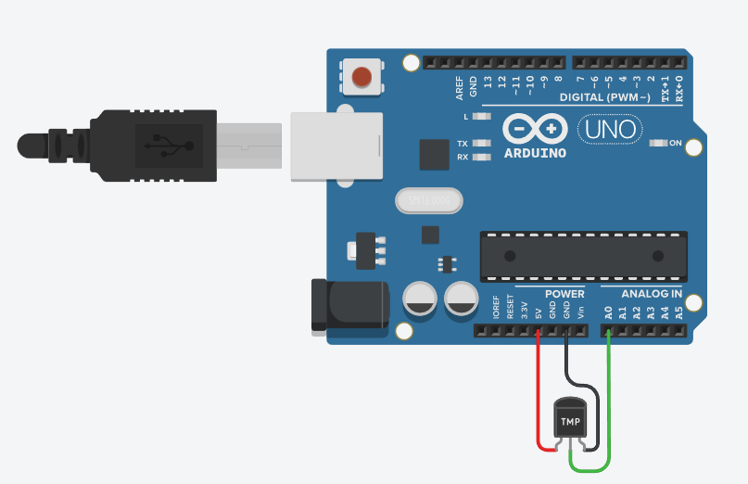

**Code :**

int OutPin = 0;

void setup()

{

Serial.begin(9600);

}

void loop()

{

int rowvoltage = analogRead(OutPin);

float millivolts = (rowvoltage/1024.0)*5000;

float celsius = millivolts/10;

Serial.print(celcius);

Serial.println(" degree celsius");

Serial.println((celcius*9)/5+32);

Serial.println(" degree Fahrenheit");

delay(100);

}

**Handwritten code :**

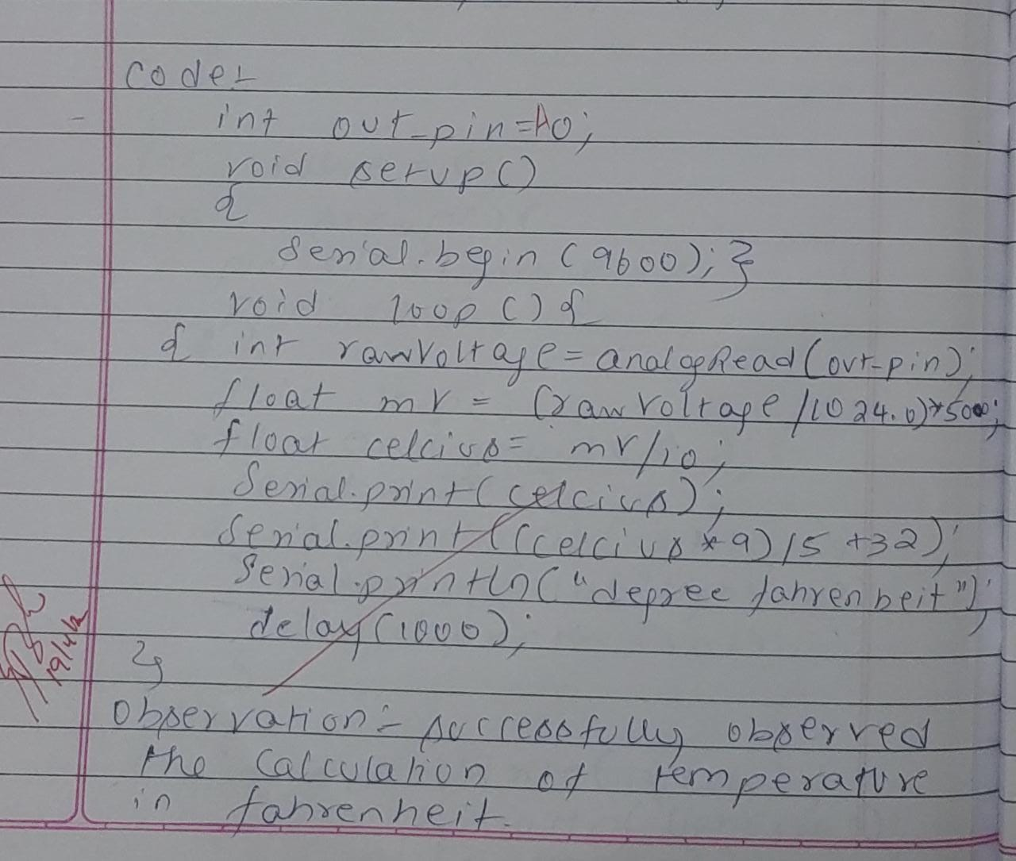

**Observation:** The current temperature in the environment is observed.

Program no: **09** Program Title: **ULTRASOUND SENSOR**

**Aim :**To measure the distance between an object using ultrasound sensor.

**Components Required :**

Arduino Uno board - 1

USB Cable - 1

LED - 1

HC - SR04 - 1

Jumper wires

**Pin Connections :**

* Pin connected to digital Pin 7
* Pin connected to analog pin 6,
* VCC pin connected to 5v of arduino
* Ground of ultrasound connected to ground of arduino

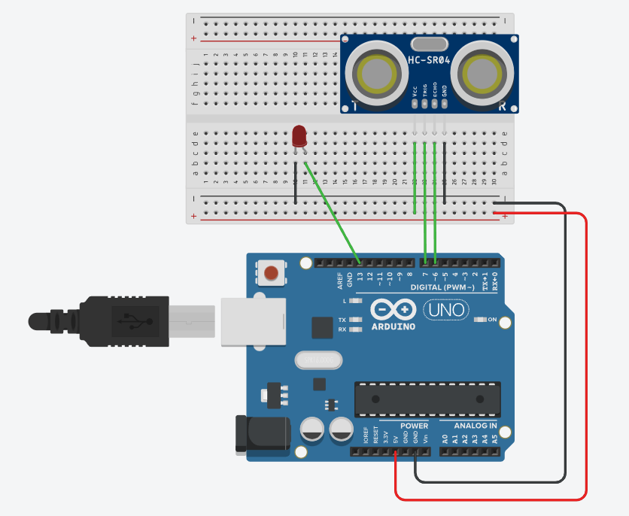

**Code :**

const int pingPin = 7;

const int echoPin = 6;

void setup()

{

Serial.begin(9600);

pinMode(pingPin, OUTPUT);

pinMode(echoPin, INPUT);

pinMode(13,OUTPUT);

}

void loop()

{

long duration, inches, cm;

digitalWrite(pingPin, LOW);

delayMicroseconds(2);

digitalWrite(pingPin, HIGH);

delayMicroseconds(10);

digitalWrite(pingPin, LOW);

duration = pulseIn(echoPin, HIGH);

inches = microsecondsToInches(duration);

cm = microsecondsToCentimeters(duration);

if(cm < 300)

{

digitalWrite(13,HIGH);

}

else

{

digitalWrite(13,LOW);

}

Serial.print(inches);

Serial.print("in, ");

Serial.print(cm);

Serial.print("cm");

Serial.println();

delay(100);

}

long microsecondsToInches(long microseconds)

{

return microseconds / 74 / 2;

}

long microsecondsToCentimeters(long microseconds)

{

return microseconds / 29 / 2;

}

**Handwritten code :**

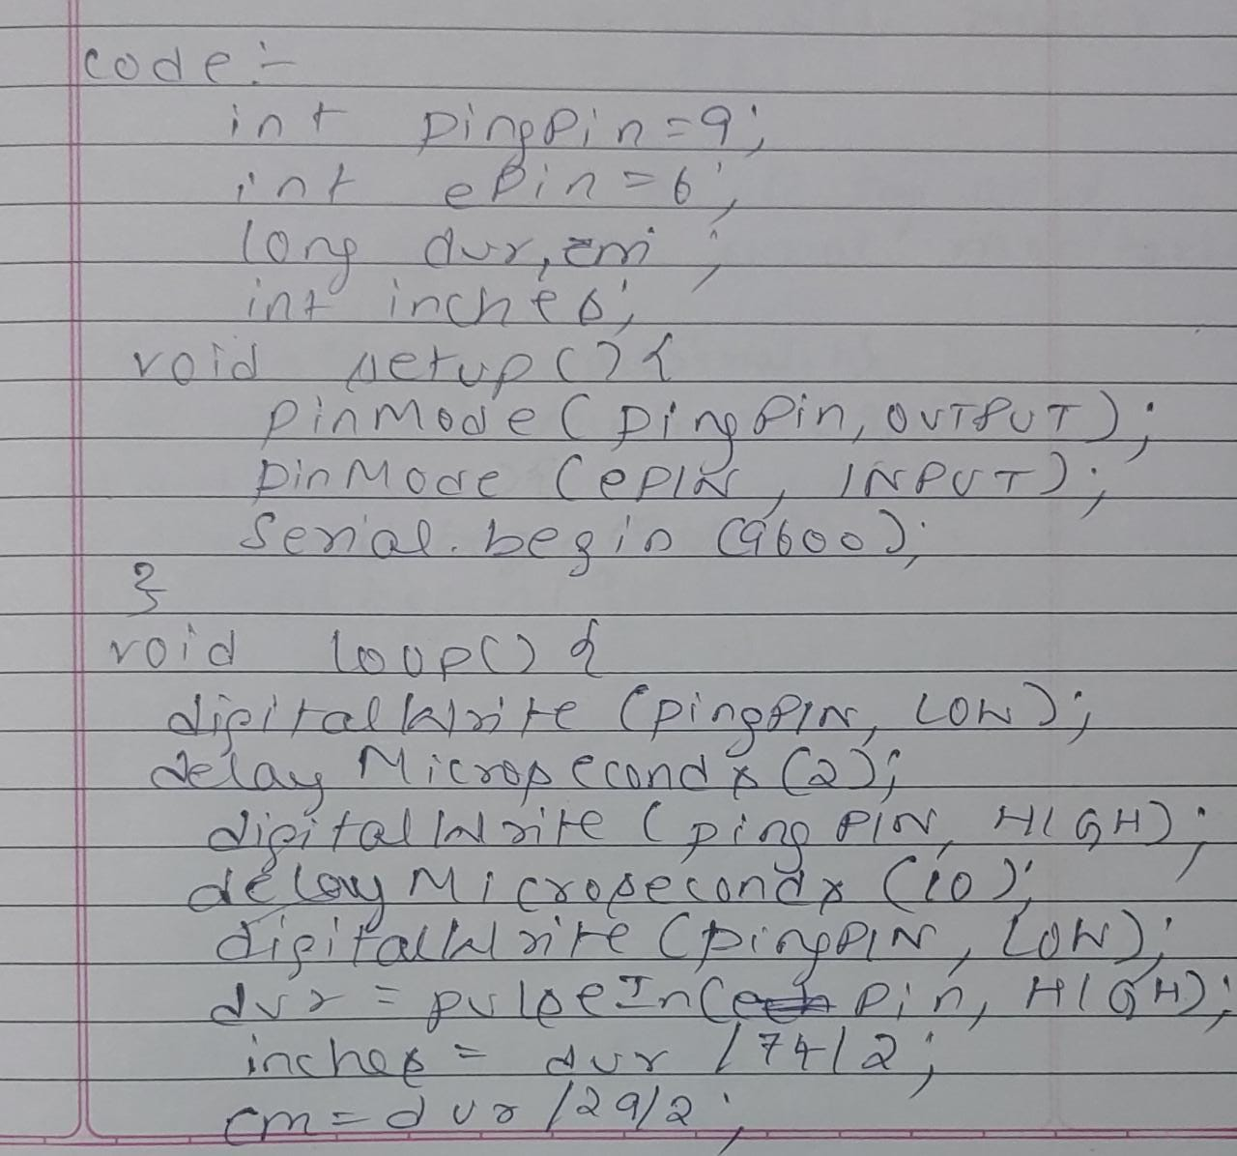

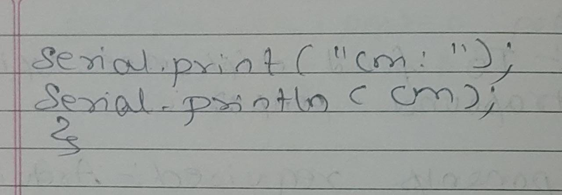

**Observation:** The distance between various objects were observed.

Program no: **10** Program Title: **NIGHT LIGHT SIMULATION WITH HUMAN PRESENCE DETECTION**

**Aim:** Nightlight Simulation with Human Presence Detection.

**Components Required :**

Arduino Uno board - 1

USB Cable - 1

Resistor(110K) - 1

LED - 1

LDR- 1

Jumper wires

**Pin Connections:**

* One leg of LDR to 5V and another leg to Arduino Analog pin A0
* One leg of 110K register with that leg of LDR connected to A0
* Another leg of register to the ground
* Positive leg of LED to pin 11 and negative to GND
* Positive leg of PIR to 5V and negative leg to GND
* Output pin of PIR to digital pin 3

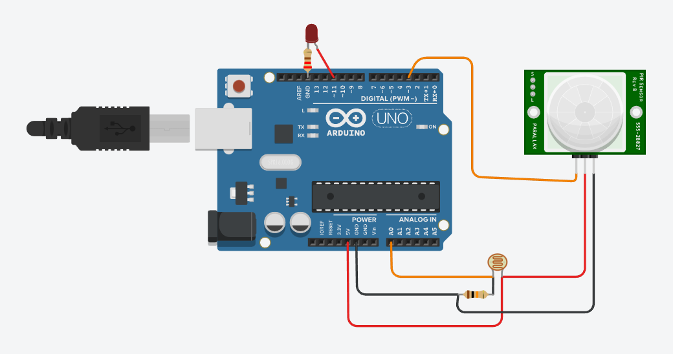

**Code:**

int LDR = 0;

LDRValue = 0;

int calibrationTime = 30

long unsigned int pause = 5000;

booleanlockLow = true;

booleantakeLowTime;

int pirPin = 3;

int ledPin = 11;

void setup()

{

Serial.begin(9600);

buadpinMode(11, OUTPUT);

pinMode(pirPin, INPUT);

pinMode(ledPin, OUTPUT);

digitalWrite(pirPin, LOW);

Serial.print("calibrating sensor ");

for(int i = 0; i<light_sensitivity)

{

digitalWrite(ledPin, HIGH);

if(lockLow)

{

lockLow = false;

Serial.println("---");

Serial.print("motion detected at ");

Serial.print(millis()/1000);

Serial.println(" sec");

delay(50);

}

takeLowTime = true;

}

if(digitalRead(pirPin) == LOW || LDRValue>= light_sensitivity)

{

digitalWrite(ledPin, LOW);

if(takeLowTime)

{

lowIn = millis();

takeLowTime = false;

}

if(!lockLow&&millis() - lowIn> pause)

{

lockLow = true;

Serial.print("motion ended at ");

Serial.print((millis() - pause)/1000);

Serial.println(" sec");

delay(50);

}

delay(100);

}

}

**Handwritten code :**

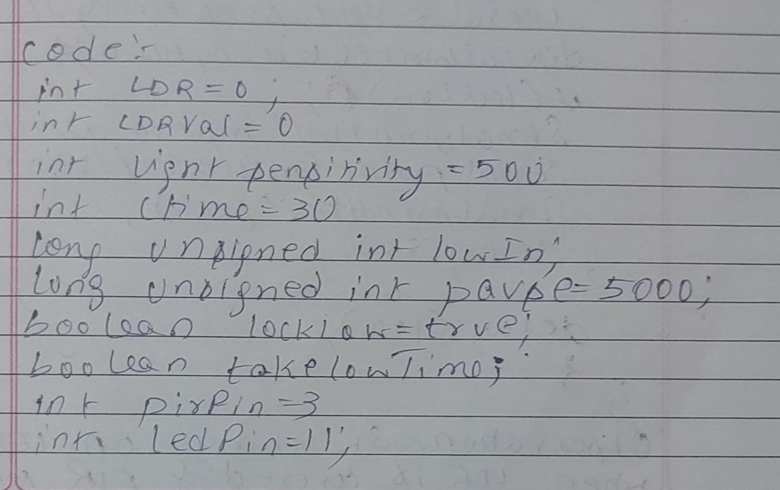

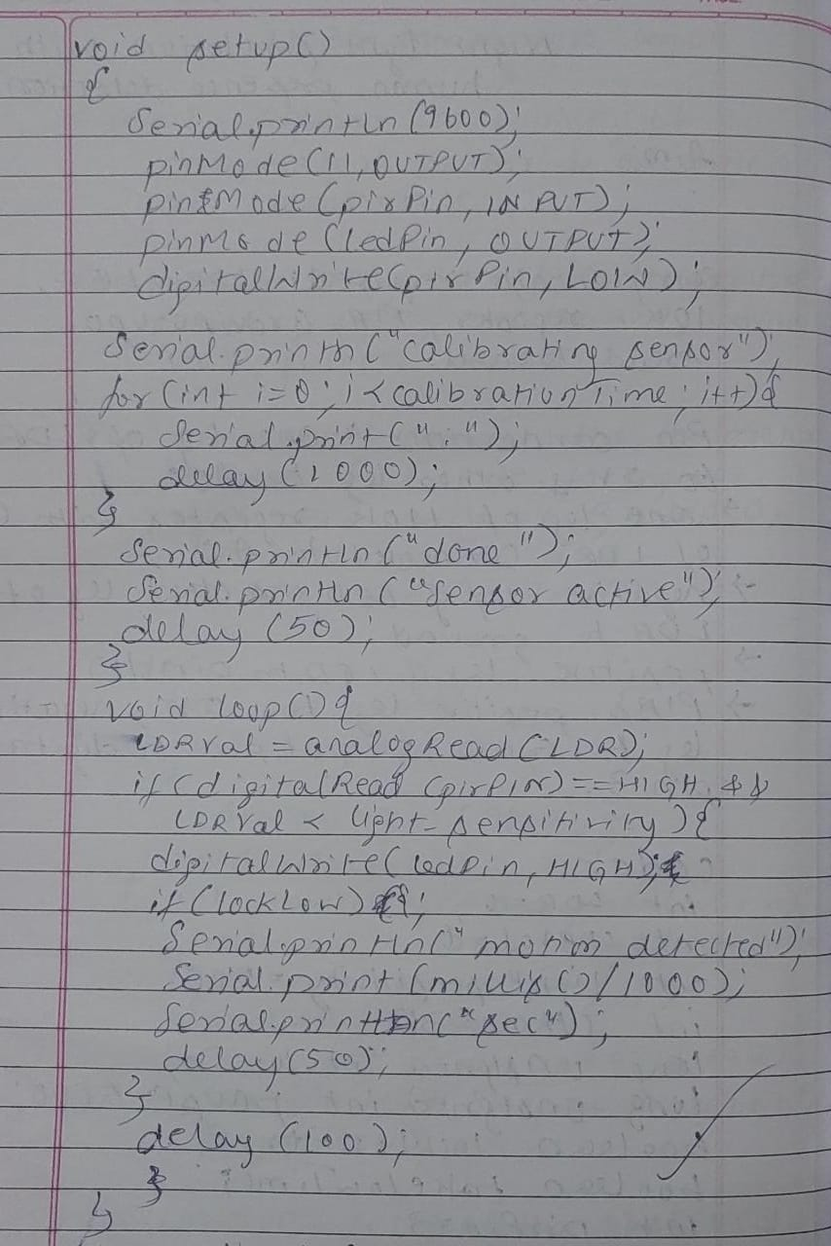

**Observation:** The LED glows while there is darkness when there is a human presence detected.

Program no: **11** Program Title: **FIRE ALERT**

**Aim:** Fire alarm simulation

**Components Required :**

Arduino Uno board - 1

USB Cable - 1

Flame Sensor - 1

LED - 1

Buzzer - 1

Jumper wires

**Pin Connections:**

* Flame sensor interfacing to Arduino
* Flame sensor to Arduino 5V -> 5V
* ground -> ground
* A0 -> A0
* Led interfacing to Arduino
* LED +ve is connected to 9th pin of Arduino
* LED -ve is connected to ground pin of arduino
* Buzzer interfacing to Arduino
* Buzzer +ve is connected to 12th pin of Arduino
* Buzzer -ve is connected to GND pin of Arduino

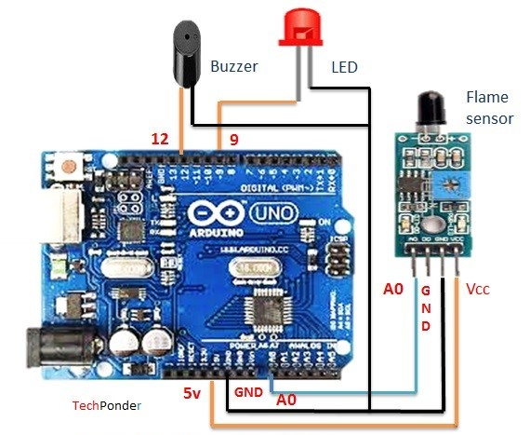

**Code:**

int sensorPin = A0;

int sensorValue = 0;

int led = 9;

void setup()

{

pinMode(led, OUTPUT);

pinMode(buzzer,OUTPUT);

Serial.begin(9600);

}

void loop()

{

Serial.println("Welcome to TechPonder Flame Sensor Tutorial");

sensorValue = analogRead(sensorPin);

Serial.println(sensorValue);

if (sensorValue< 100)

{

Serial.println("Fire Detected");

Serial.println("LED on");

digitalWrite(led,HIGH);

digitalWrite(buzzer,HIGH);

delay(1000);

}

digitalWrite(led,LOW);

digitalWrite(buzzer,LOW);

delay(sensorValue);

}

**Handwritten code :**

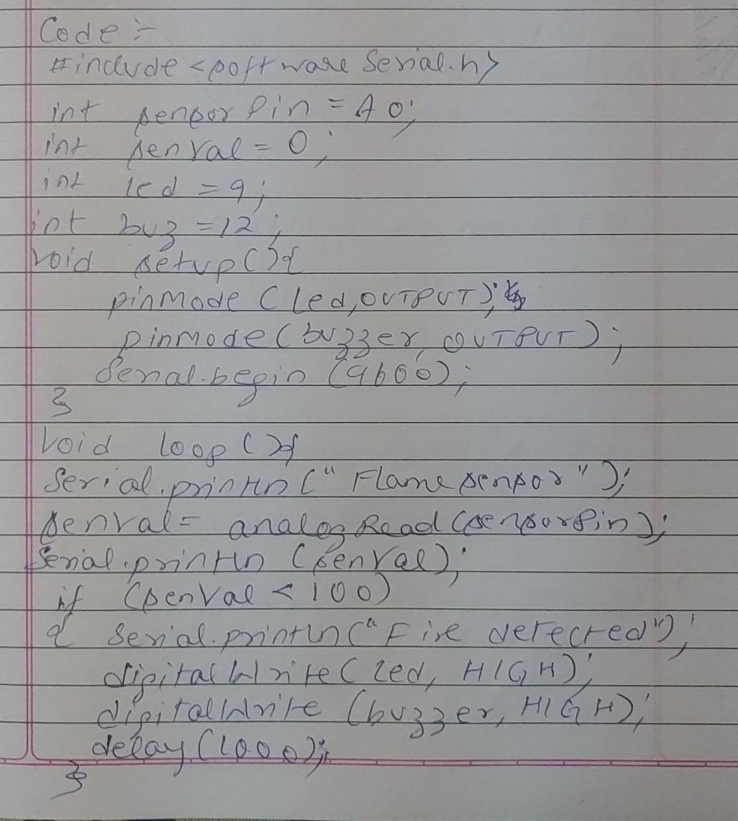

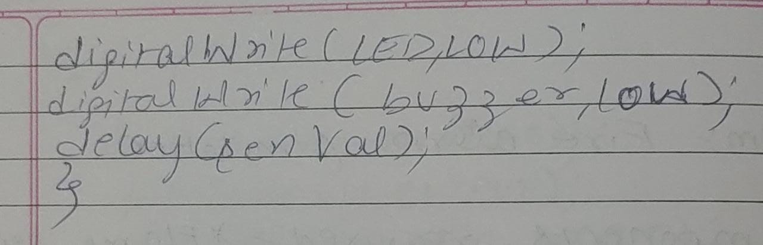

**Observation:** The fire alarm goes off when fire or hotness is detected.

Program no: **12** Program Title: **AUTOMATIC IRRIGATION CONTROLLER SIMULATION**

**Aim:** Sensing the soil moisture and sprinkling the Water simulation

**Components Required :**

Arduino Uno board - 1

USB Cable - 1

Min Servo Motor - 1

Moisture Sensor - 1

LED - 1

Buzzer - 1

Jumper wires

**Pin Connections:**

* Moisture sensor VCC to Arduino 5V
* Moisture sensor GND to Arduino GND
* Moisture sensor A0 to Arduino A0
* Servo motor VCC to Arduino 5V
* Servo motor GND to Arduino GND
* Servo Motor Signal to Arduino digital pin 9

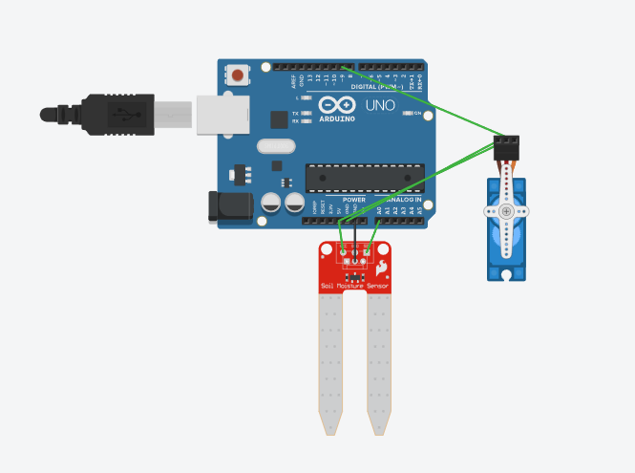

**Code:**

#include Servo myservo;

int pos = 0;

int sensorPin = A0;

int sensorValue = 0;

void setup()

{

myservo.attach(9);

Serial.begin(9600);

}

void loop()

{

sensorValue = analogRead(sensorPin);

Serial.println (sensorValue);

if(sensorValue>500)

{

for (pos = 0; pos<= 180; pos += 1)

{

{

myservo.write(pos);

delay(15);

}

for (pos = 180; pos>= 0; pos -= 1)

{

myservo.write(pos);

delay(15);

}

}

delay (1000);

}

**Handwritten code :**

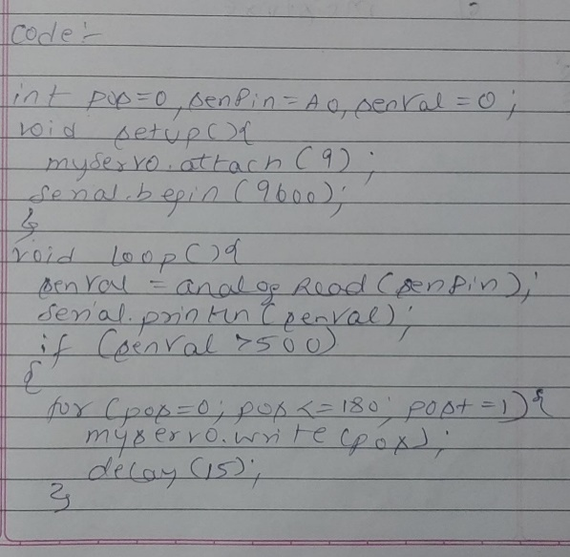

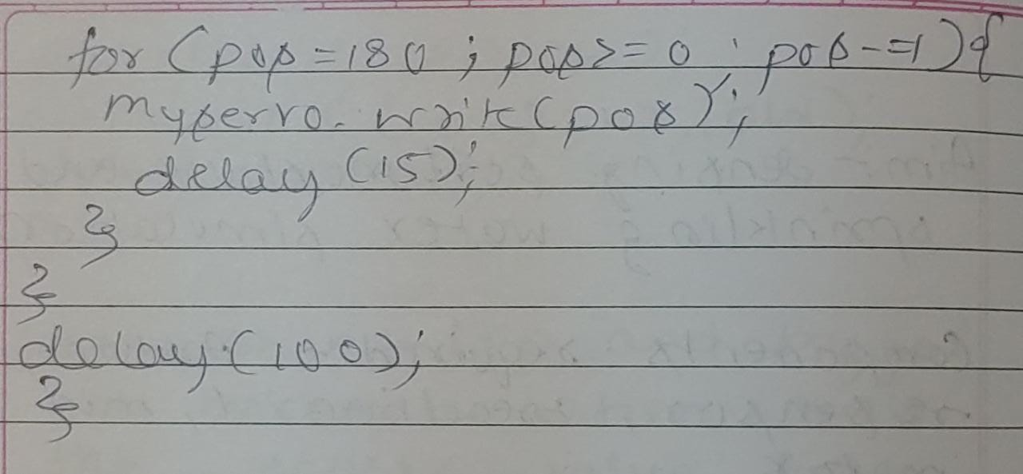

**Observation:** The water sensor goes off when the lack of moisture content is sensed.

Program no: **13** Program Title: **RFID READER AND ACCESS CONTROL**

Aim: To count the number of RFID tags read by the RFID reader

**Components Required :**

Arduino Uno board - 1

USB Cable - 1

RFID reader module - 1

RFID tags - 1

Jumper wires

**Pin Connections:**

* Arduino ground to RFID ground
* TX(RFID) to 9(RX) arduino
* VCC USB Port to 12 RFID reader

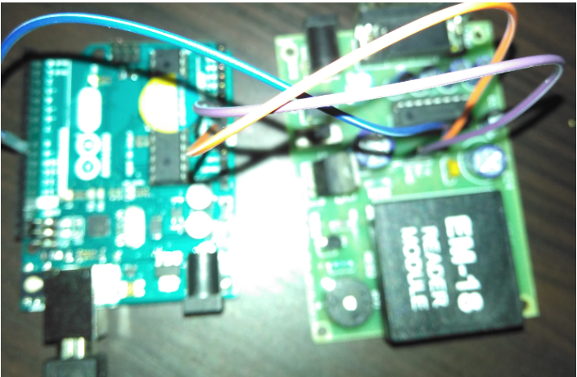

**Code:**

void setup()

{

Serial.begin(9600);

}

void loop()

{

if(Serial.available()>0)

{

Serial.write(Serial.read());

}

}

**Handwritten code :**

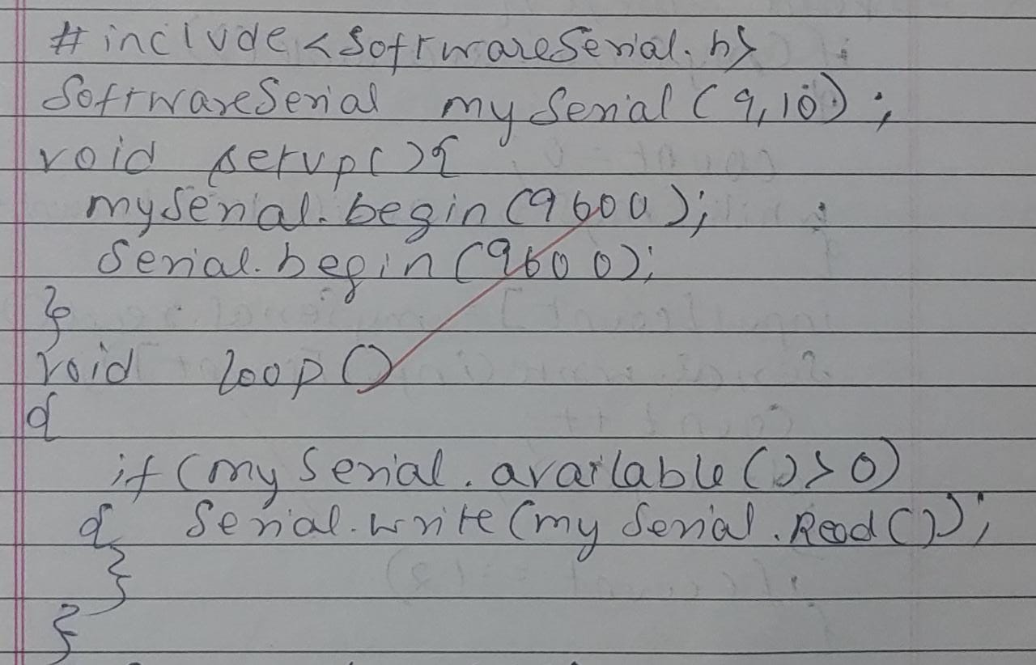

**Observation:** The RFID card is detected when brought closer to the RFID reader.

Program no: **14** Program Title: **ACCESS BASED ON RFID TAG**

Aim: To demonstrate the use of the RFID tag for access control

**Components Required :**

Arduino Uno board - 1

USB Cable - 1

RFID reader EM -18 - 1

RFID tags - 1

RFID Tag Reader - 1

Jumper wires

**Pin Connections :**

* 5V to VCC of base Tag
* Ground of Arduino to ground of the base of the tag
* RX of arduino to TX of EM-18

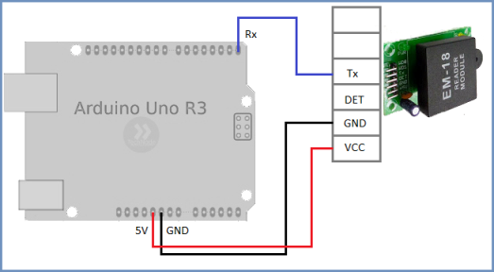

**Code :**

#include <softwareSerial.h>

SoftwareSerialMySerial (9,10);

#define LEDPIN 12

char tag[] = “3C0087D597F9”  
 char input[12];

int count = 0;

input[] character array

char input[12];

int count = 0;

input[] character array

char input[12];

int count = 0;

boolean flag = 0;

void setup {}

{

Serial.begin(9600);

Monitor

Serial.begin(9600);

pinMode(LEDPIN, OUTPUT);

}

void loop {}

{

if(MySerial.available());

{

count=0;

while(MySerial.available()&& count<12)

{

input[count]=Myserial.read();

Serial.Write(input[count]);

count ++;

delay(5);

}

if(count==12)

{

flag=1;

while(count=12; && flag!=0)

{

if(input[count]==flag[count])

flag=1;

else

flag=0;

count++;

}

}

if(flag==1)

Serial.println(“Access Allowed”);

digitalWrite(LEDPIN,HIGH);

delay(2000)

digitalWrite(LEDPIN,LOW);

}

else

{

Serial.println(“Access denied”);

digitalWrite(LEDPIN,LOW);

delay(2000);

}

for(count=0;count<12;count++)

{

input[count]= ‘F’

}

count=0;

}

}

**Handwritten code :**

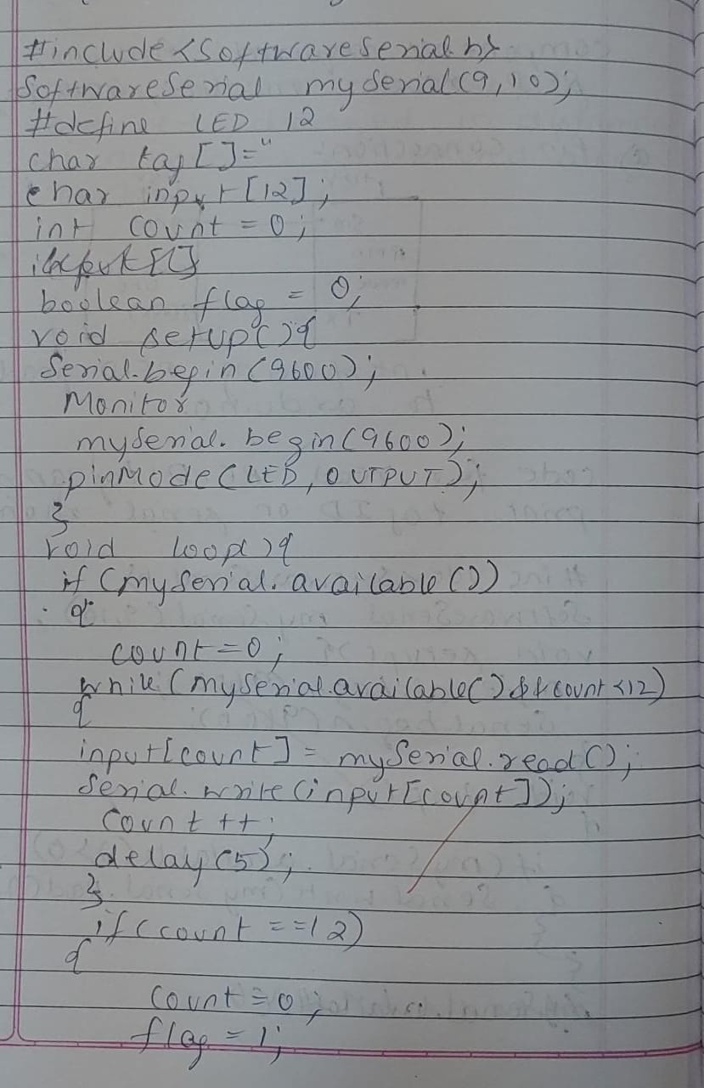

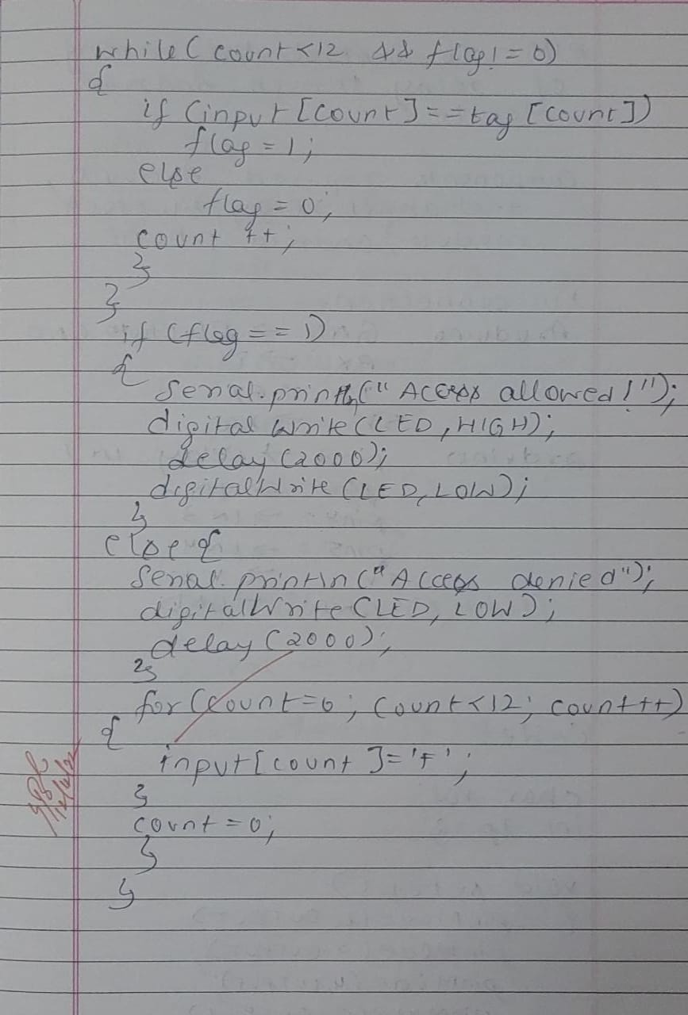

**Observation:** Access is allowed when the card designated is recognized by the RFID tag reader.

Program no: **15** Program Title: **HOME AUTOMATION(COMMAND PROMPT)**

**Aim:** To establish the working of home automation.

**Components Required :**

Arduino Uno board - 1

USB Cable - 1

Bluetooth model - 1

Breadboard - 1

Jumper wires

**Pin Connections :**

* LED positive pin to digital 13
* LED negative pin to ground
* Bluetooth TX to arduino RX
* Bluetooth RX to arduino TX
* Bluetooth ground pin to ground
* Bluetooth VCC pin to VCC(5V)

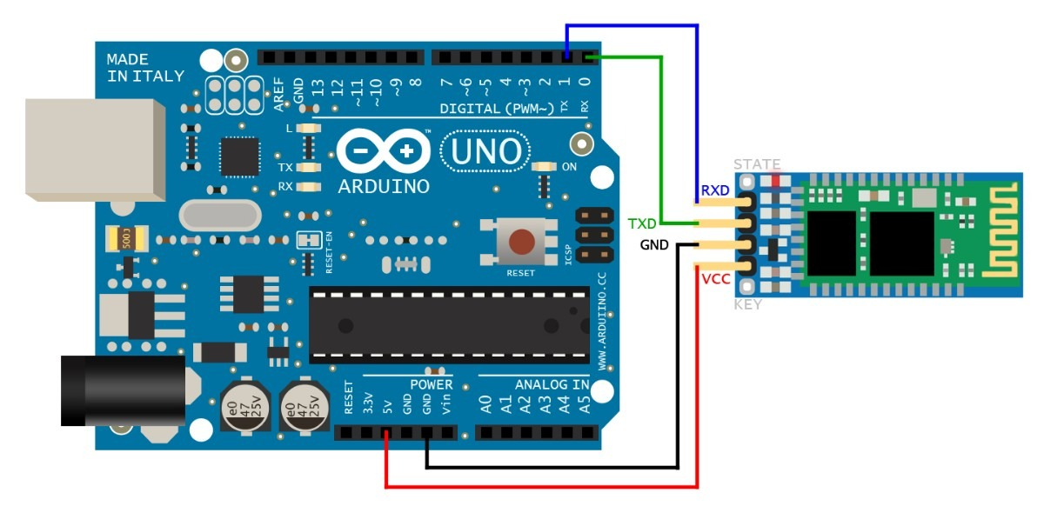

**Code :**

#include SoftwareSerialBTSerial(10, 11);

void setup()

{

Serial.begin(9600);

Serial.println("Enter AT commands:");

BTSerial.begin(38400);

}

void loop()

{

Serial.write(BTSerial.read());

BTSerial.write(Serial.read());

}

**Handwritten code :**

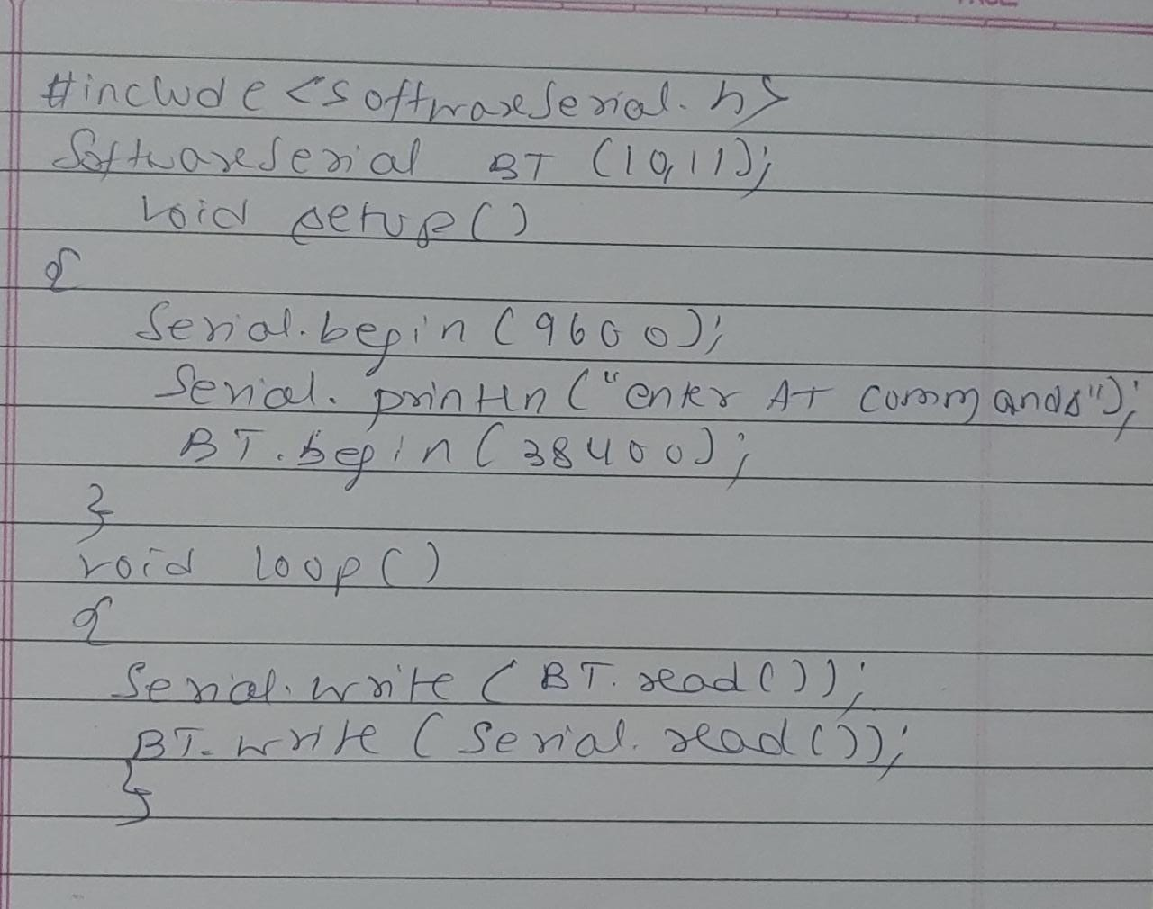

**Observation:** The Username and password for an automated home unit is set up successfully.

Program no: **16**  Program Title: **HOME AUTOMATION(LED CONTROL)**

**Aim:** To see the working of LED control with the help of an android mobile application.

**Components Required :**

Arduino Uno board - 1

USB Cable - 1

Bluetooth model - 1

Android Phone - 1

Breadboard - 1

Jumper wires

Arduino Bluetooth App

**Pin Connections :**

* LED positive pin to digital 13
* LED negative pin to ground
* Bluetooth TX to arduino RX
* Bluetooth RX to arduino TX
* Bluetooth ground pin to ground
* Bluetooth VCC pin to VCC(5V)

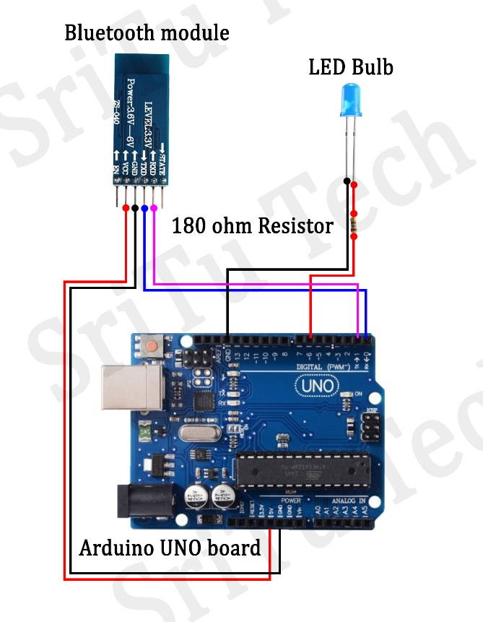

**Code :**

#defineledPin 13

int state = 0;

void setup()

{

pinMode(ledPin, OUTPUT);

digitalWrite(ledPin, LOW);

Serial.begin(38400);

}

void loop()

{

if(Serial.available() > 0)

if (state == '0')

{

digitalWrite(ledPin, LOW);

Serial.println("LED: OFF");

state = 0;

}

else if (state == '1')

{

digitalWrite(ledPin, HIGH);

Serial.println("LED: ON");;

state = 0;

}

**Handwritten code :**

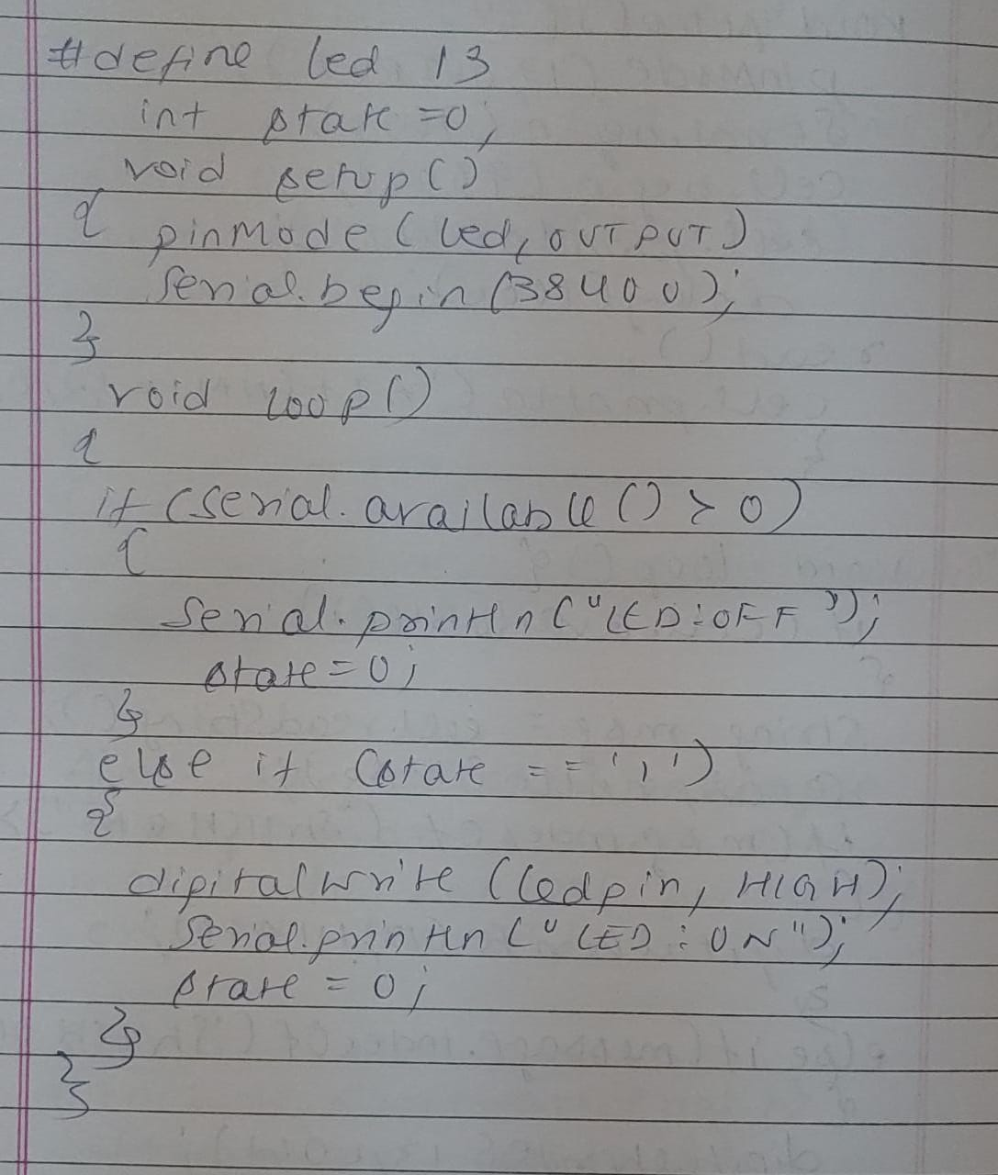

**Observation:** Using the username and password that was established in the previous experiment, the LED was switched ON/OFF using the android mobile application.

Program no: **17** Program Title: **HOME AUTOMATION(RELAY)**

**Aim:** To see the working of LED control with the help of an android mobile application.

**Components Required :**

Arduino Uno board - 1

USB Cable - 1

Bluetooth model - 1

Android Phone - 1

4 - Channel Relay - 1

Breadboard - 1

Jumper wires

Arduino Bluetooth App

**Pin Connections :**

* Output 1 to Pin 2 ( Arduino Board )
* Output 2 to Pin 3
* Output 3 to Pin 4
* Output 4 to Pin 5
* Bluetooth Module Tx to Pin 0
* Bluetooth Module Rx to Pin 1
* VCC of Bluetooth & relay should be connected to Arduino 5V(through breadboard)
* GND of Bluetooth & relay should be connected to Arduino GND

**Code :**

char val;

int ledpin = 2;

void setup()

{

pinMode(ledpin = 2, OUTPUT);

pinMode(ledpin = 3, OUTPUT);

pinMode(ledpin = 4, OUTPUT);

pinMode(ledpin = 5, OUTPUT);

Serial.begin(9600);

}

void loop()

{

if( Serial.available()

{

;

}

val = Serial.read();

if( val == 'a' )

{

digitalWrite(ledpin = 2, HIGH);

}

if( val == 'A' )

{

digitalWrite(ledpin = 2, LOW);

}

if( val == 'b' )

{

digitalWrite(ledpin = 3, HIGH);

}

if( val == 'B' )

{

digitalWrite(ledpin = 3, LOW);

}

if( val == 'C' )

{

digitalWrite(ledpin=4, LOW);

}

if( val == 'D' )

{

digitalWrite(ledpin=5, LOW);

}

if( val == 'c' )

{

digitalWrite(ledpin = 4, HIGH);

}

if( val == 'd' )

{

digitalWrite(ledpin = 5, HIGH);

}

}

**Handwritten code :**

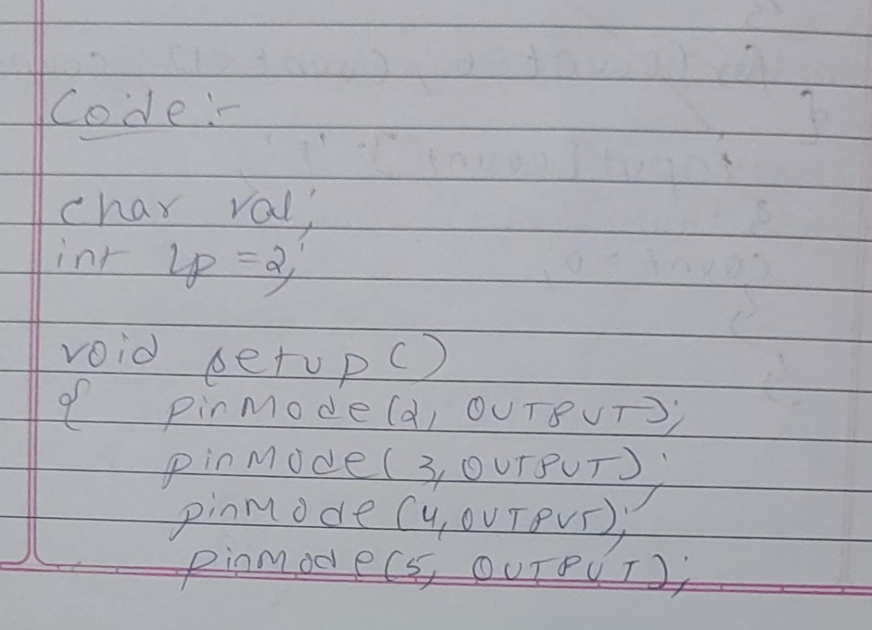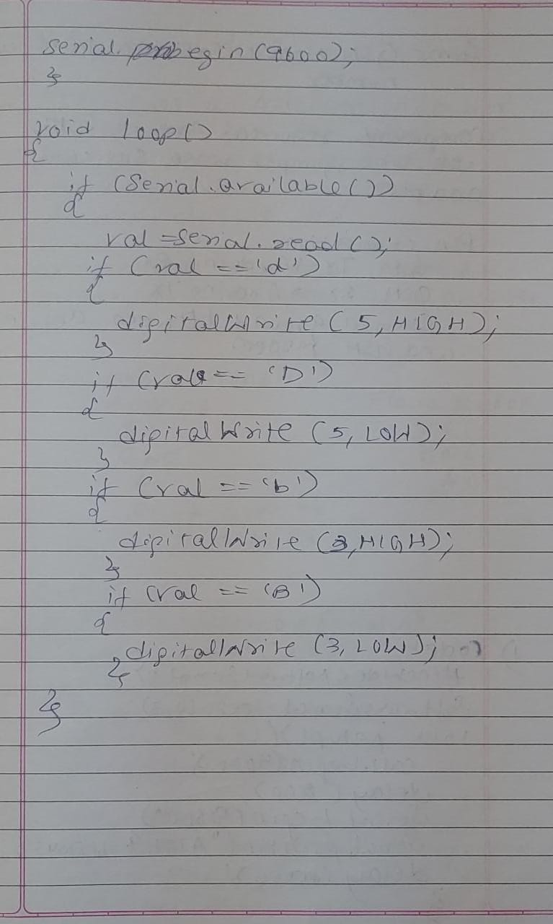

**Observation:** Home automation commands when connected through relay.

Program no: **18** Program Title: **PROGRAMMING ARDUINO WITH GSM MODULE**

**Aim:** To Program Arduino with GSM Module

**Components Required :**

Arduino Uno board - 1

USB Cable - 1

GSM module - 1

Android Phone - 1

Airtel SIM card - 1

Breadboard - 1

Flame Sensor(For flame sensor program) - 1

Jumper wires

**Pin Connections:**

• GSM Tx –>Arduino Rx (Here pin 2)

• GSM Rx –>ArduinoTx. (Here pin 3)

• Make the ground common between Arduino and GSM modem

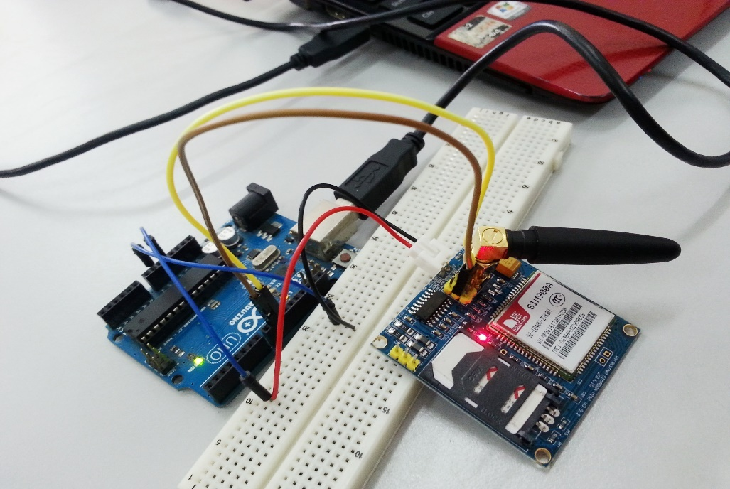

1. **GSM Module: Call to a particular number**

**Aim :** Call using Arduino and GSM Module – to a specific mobile number inside the program.

**Code :**

#include SoftwareSerialcell(2,3);

void setup()

{

cell.begin(9600);

delay(500);

Serial.begin(9600);

Serial.println("CALLING..........");

cell.println("ATD+919538433364;");

}

void loop()

}

**Handwritten code :**

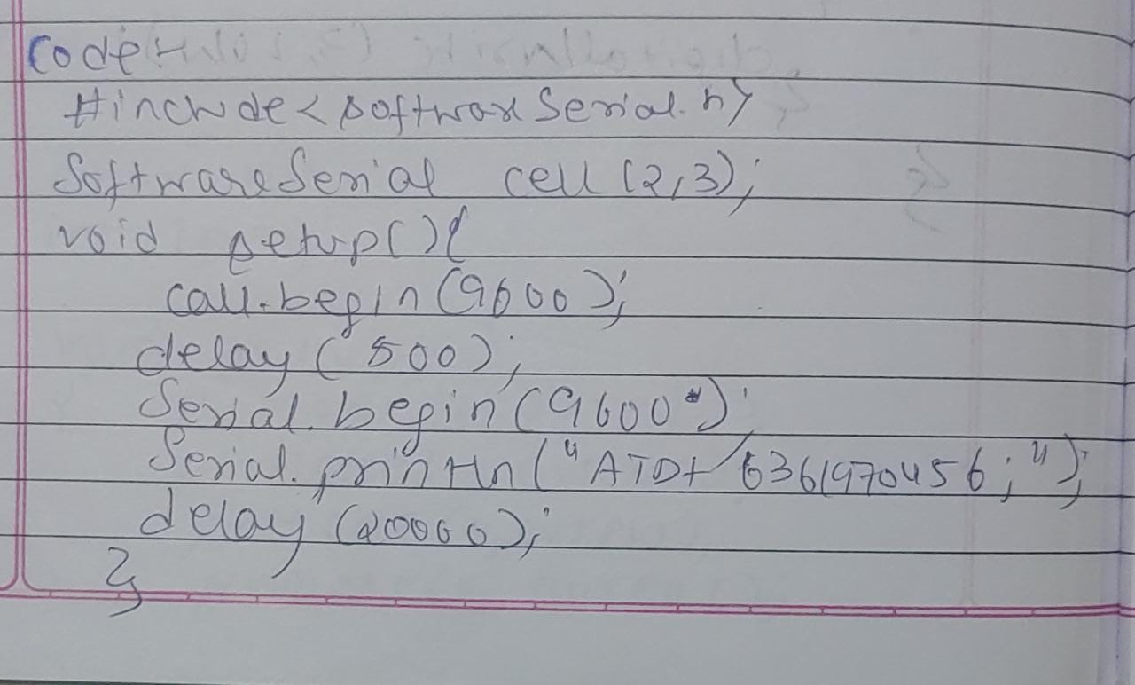

**Observation:** Using a specific number calls were made and received by the GSM module.

1. **Call to a particular number on an alert**

**Aim :** Call a specified mobile number mentioned in the program using Arduino and GSM Module when a flame sensor detects “fire”.

**Connections for flame sensor:**

Arduino to Flame Sensor

5V to VCC

GND to GND

**Code :**

#include SoftwareSerialcell(2,3);

void setup()

{

cell.begin(9600);

delay(500);

Serial.begin(9600);

}

void loop()

{

int val=analogRead(A0);

Serial.println(val);

delay(1000);

if (val<50)

{

Serial.println(“Calling………..”);

cell.println(“ATD+916361970456;”);

delay(10000);

cell.println(“ATH”);

}

}

**Handwritten code :**

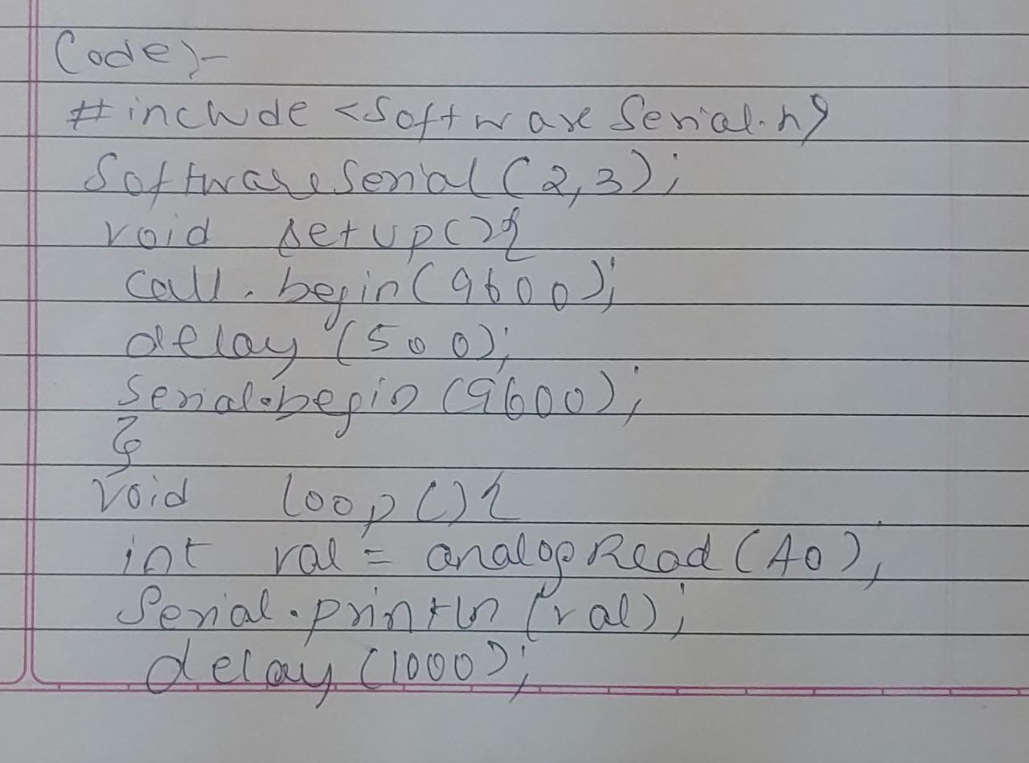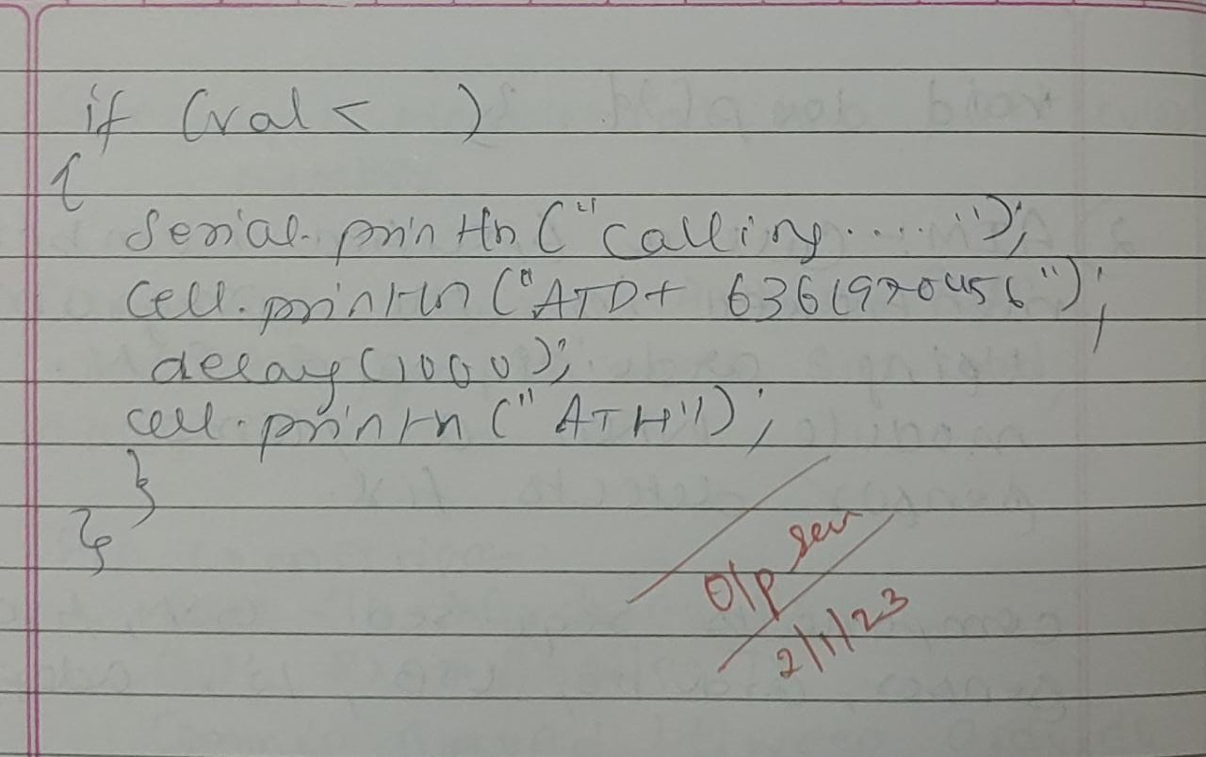

**Observation:** Calls were made by the GSM module to a specific number when fire/flame was detected.

1. **Sending and Receiving Message**

**Aim:**

1. Send SMS using Arduino and GSM Module – to a specific mobile number inside the program
2. 2) Receive SMS using Arduino and GSM Module – to the SIM card loaded in the GSM Module. Program: Note: According to the code, messages will be sent and received when ‘s’ and ‘r’ are pressed through the serial monitor respectively.

**Code :**

#include SoftwareSerialmySerial(2, 3);

void setup()

{

mySerial.begin(9600);

Serial.begin(9600);

delay(100);

}

void loop()

{

if (Serial.available()>0)

switch(Serial.read())

{

case 's': SendMessage();

break;

case 'r': ReceiveMessage();

break;

}

if (mySerial.available()>0)

Serial.write(mySerial.read());

}

voidSendMessage()

{

mySerial.println("AT+CMGF=1");

delay(1000);

mySerial.println("AT+CMGS=\"+919742980606\"\r");

delay(1000);

mySerial.println("I am SMS from GSM Module");

delay(100);

mySerial.println((char)26);

delay(1000);

}

void ReceiveMessage()

{

mySerial.println("AT+CNMI=2,2,0,0,0");

delay(1000);

}

**Handwritten code :**

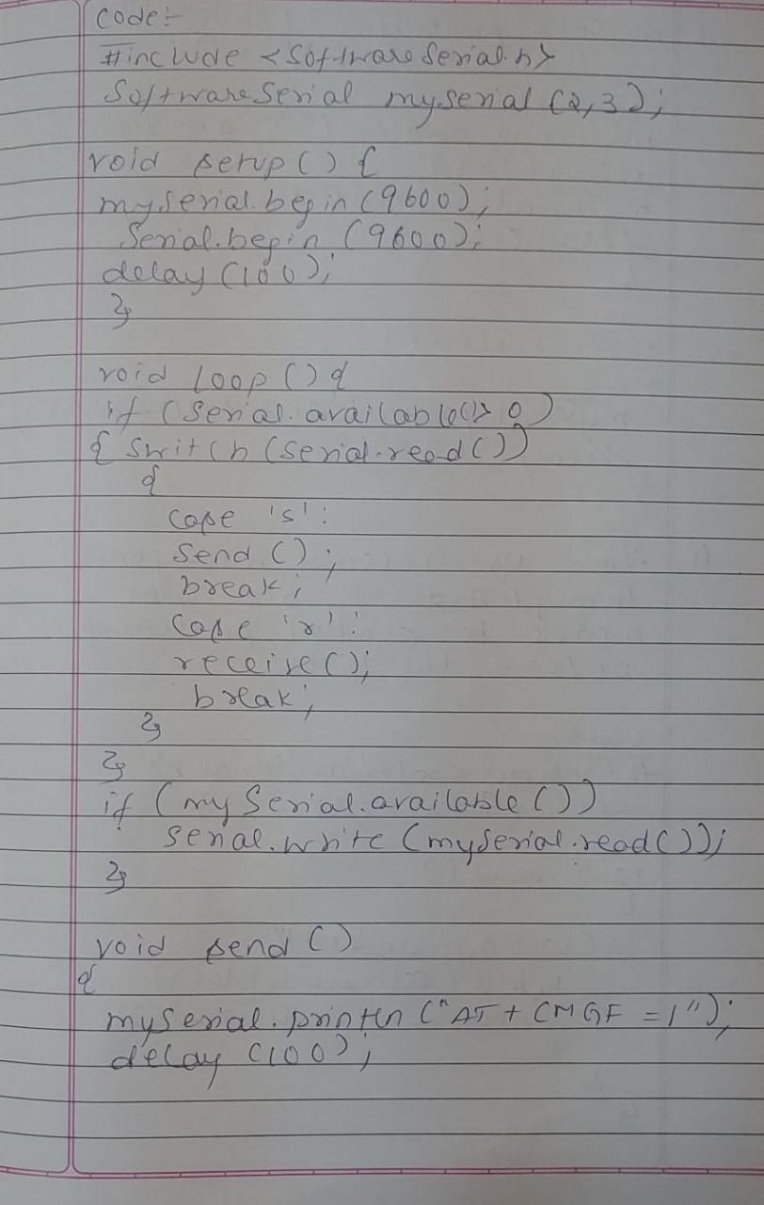

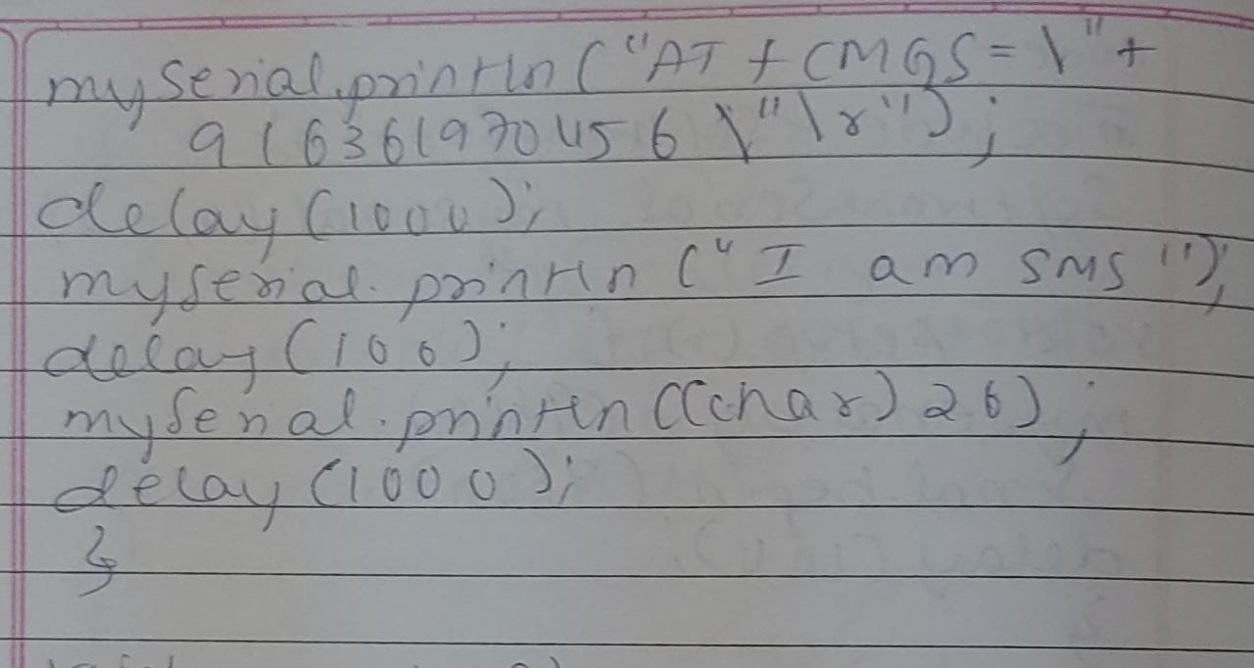

**Observation:** Messages were sent and received to and from the GSM module.

1. **Controlling LED through received messages:**

**Aim:** Use received messages through Arduino and GSM Module to control Switching ON/OFF the LED.

**Pin Connections:**

* Attach LED to pin 13 and GND.

**Code :**

#include SoftwareSerialcell(2,3);

voidreadfn()

{

if (cell.available())

{

while (cell.available())

{

Serial.write(cell.read());

}}}

void setup()

{

pinMode(13,OUTPUT);

Serial.begin(9600);

cell.begin(9600);

cell.println("AT");

delay(1000);

readfn();

}

void loop()

{

if(cell.available())

{

String message =cell.readString();

Serial.println(message);

if(message.indexOf("SWITCH ON")>0)

{

digitalWrite(13,HIGH);

}

else

if(message.indexOf("SWITCH OFF")>0)

{

digitalWrite(13,LOW);

}

else

{

Serial.println ("Nothing to do...");

}}

}

**Handwritten code :**

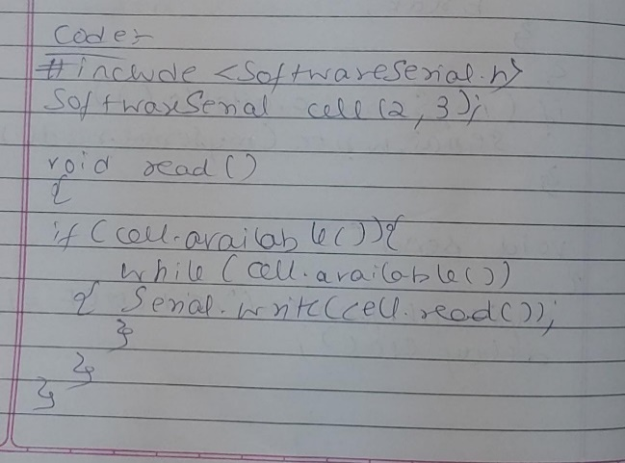

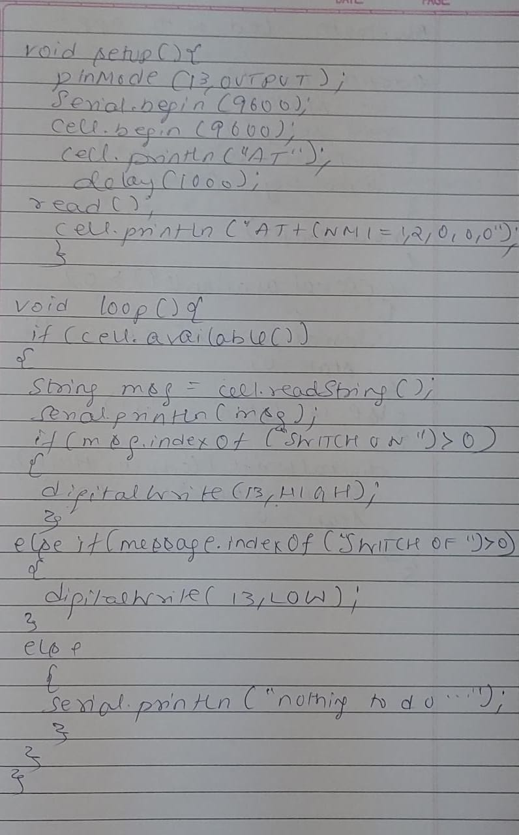

**Observation:** Received messages through Arduino and GSM Module to control Switching ON/OFF the LED